Design Challenge Report: The Nintendo Switch

Accessibility and Inclusive Design

Tim Huynh
Laura K
Swakirti S
Tammy T
Siqing Z

Executive Summary
This report examines the barriers that low-vision users face when using the Nintendo Switch and proposes a redesign that helps mitigate these barriers.
In a span of two months, the team started by understanding the product, the users, and potential barriers that disabled users might face in a larger scope. Next, through conducting primary and secondary research, the team narrowed the scope to low-vision users and identified major issues to redesign. A few prototypes and mockups were then developed and evaluated by representative users who had either first-hand or second-hand experience. Then the team iterated the solutions according to user feedback.
The final redesign includes the following features:
- Sticker sheets for colored and raised letters on the controller buttons
- Flexible font- and UI-scaling at the system level
- Pre-set color filters allowing customizations
Despite a few limitations in our redesign, we hope it will work to raise accessibility awareness and inclusive design in the gaming industry. We are hope that game makers will build more accessible games and devices in the future.
Our next steps include seeking more feedback from low-vision players and iterating our solutions, producing interactive prototypes, and addressing the issues and consequences that would result from our solutions.

1. System Description
The Nintendo Switch is a video game system developed by Nintendo, and the company’s mission is “to put smiles on the faces of everyone we touch” (Nintendo, n.d.). It is composed of a console, a dock, a pair of controllers known as Joy-Cons, and its software.
The Switch was first released in 2017. The Joy-Cons can be attached to the console or detached from it. These options let gamers play in handheld, tabletop, or TV-connected modes. In 2019, Nintendo Switch Lite was released as a handheld-only device with a relatively lower price.
Nintendo Switch users can be anyone interested in playing video games. They vary in age, preferred genre, location, language and culture, experience and skill, physical and cognitive ability, and so on. They can play alone or with others in-person or online.

2. Problem Context
To understand the problem space, we conducted a cycle-of-exclusion exercise and looked at who made the product, why it was made, how it was made, who it was made for, and who are the actual users. We also examined the current accessibility-features and found existing solutions in this field. There are options for controller-button remapping, zoom level, color inversion, and greyscale. An adaptive controller for the Switch was recently released in Japan.
However, we have found that there is a huge gap to fill after empathizing with gamers who have disabilities in motor, audio, visual, motor and financial aspects. For instance, users need both hands to play with the Switch Lite, there are no in-game visual cues indicating the directions that sounds come from, the text and UI are tiny, and there is a lack of visual contrast between UI and the background. In addition, the Switch may be too expensive for many people.
To narrow the scope of our project, we decided to focus our efforts on the low-vision user group. After conducting secondary research such as reading research papers, searching for opinions expressed by players with disabilities on social media, the Game Accessibility Guidelines website, and conducting competitor analysis, we identified five specific barriers that low-vision gamers face:
- Same button colors on the controllers
- Small font and UI
- Lack of contrast between UI and the background
- No text-to-speech feature
- No directional pointers to indicate sound direction

After talking to inclusive-design expert Bryce Johnson and a representative user, we gained a better understanding of possible constraints and possibilities. We decided to focus our project on the following three issues:
- Same button colors on the controllers
- Small text and UI
- Lack of contrast between UI and background

3. Problem Statements
The following problem statements have been developed based on our secondary and primary research.

3.1. Colored Buttons
Low-vision players, especially if less experienced, want the face buttons to be more salient for easier reference.
Players should not have to memorize the standard scheme. Although Nintendo has used the same layout and letters for its four face-buttons since the early 1990s, not everyone is familiar with this scheme. Depending on the Switch model, the buttons might not be easy to perceive by sight or by feel. Because Joy-Con controllers can be held in various orientations, in-game and in-person references to the standard scheme can be moot.

3.2. Font Scaling
Low-vision players want text to be more readable.
Players might feel discomfort and eye strain from reading small text (e.g. Thompson, 2018; Saylor, 2019). They should be able to change the text size. These changes should be easy to make, previewable, customizable, applicable to as many applications as possible, and automatically reflected in related elements, such as UI containers.

3.3. Screen Filters
Low-vision players want on-screen elements to be more visible.
Players should be able to modify filters. These changes should be easy to make and previewable. Brightness, contrast, and saturation/vibrancy should be changeable. Both pre-sets and customization should exist.
Different types of games have different color schemes. As seen in Figure 3.3a, horror games tend to be darker, while adventure games are brighter. For users with low-vision, these games can be difficult to play because important features are hard to see.

Figure 3.3a
Color Schemes in a Horror Game and an Adventure Game
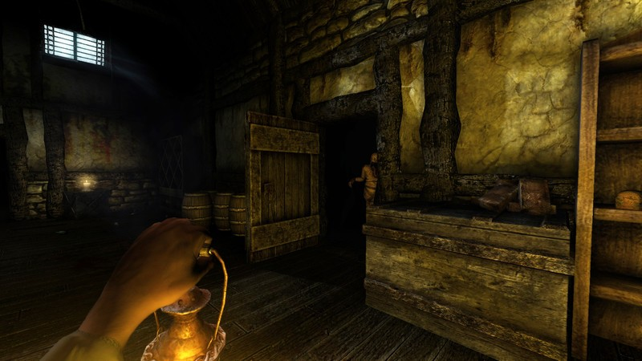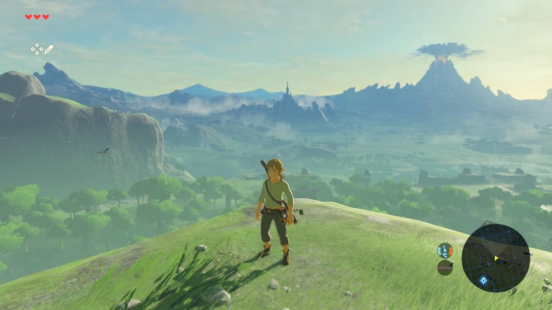
The first image is Amnesia: The Dark Descent for Nintendo Switch (Frictional Games, n.d.). The second image is Legend of Zelda: Breath of the Wild for Nintendo Switch (Gratis, 2017)

4. Users and Their Context
The target users of this project are Switch players who have low vision, that is, players who are not totally blind. We had originally considered helping blind players as well, but we narrowed our base to low-vision players.
To understand these users and their context, we sought user stories from Switch players via GameFAQs, a popular gaming message board (Huynh, 2020). We also applied learning outcomes from an undergraduate course in cognitive psychology that studied sensory and perception.
In general, vision impairments can vary in type and severity. These impairments can be congenital or emergent later in life. The latter can be incidentally acquired or genetically inherited. Vision impairments can hinder how people sense/perceive various aspects of the world.
- Details
- Colors
- Lights
- Fields of view
- Motion
- Depth/distance
- Complex stimuli
In terms of gaming, these vision impairments can significantly affect their choices and outcomes. They might avoid or favor certain game genres, multiplayer situations, screen sizes or resolutions, distances to screens, and game or system features. While playing games, they might experience higher rates of failure, longer times to success, cognitive unease, and physical discomfort or pain because of their vision impairment(s).
The goals of low-vision players are no different than those of other players, but depending on their impairments, they have particular needs and desires:
- Larger elements (icons, text)
- Exaggerated effects and highlights (silhouettes, trails)
- Directional indicators
- Non-color attributes
- Extended time-limits
- Controllable pace

5. Other Work in This Area

5.1. Colored buttons
Colored buttons are adapted in many industries for making products accessible for everyone. In 2013, Xbox One launched a new controller that included colored buttons. These buttons addressed accessibility issues related to the controller. In November 2020, when everything about the new controller was iterated and improved, only the colored buttons remained the same (Craven, 2020b). Colored buttons help users who have dyslexia and those who prefer to identify the buttons by color. Additionally, every user who is using different controllers at different times would also benefit.
Similarly, Sony’s PlayStation controller buttons traditionally have different shapes combined with colors. Sony opted for shapes instead of letters, but colors were an essential feature until their PlayStation 4 (PS4) controller was released.
In November 2020, the PlayStation 5 (PS5) has launched with a controller that has no colors on it. The designer defines this choice as simplification of design (Patterson, 2020). In contrast, Microsoft designer Bryce Johnson (personal communication, November 5, 2020) stressed that his colleagues made sure a controller with colored buttons would be part of their design. According to their data, this design helps their users.

Figure 5.1a
PlayStation 4 Controller
Figure 5.1b
PlayStation 5 Controller
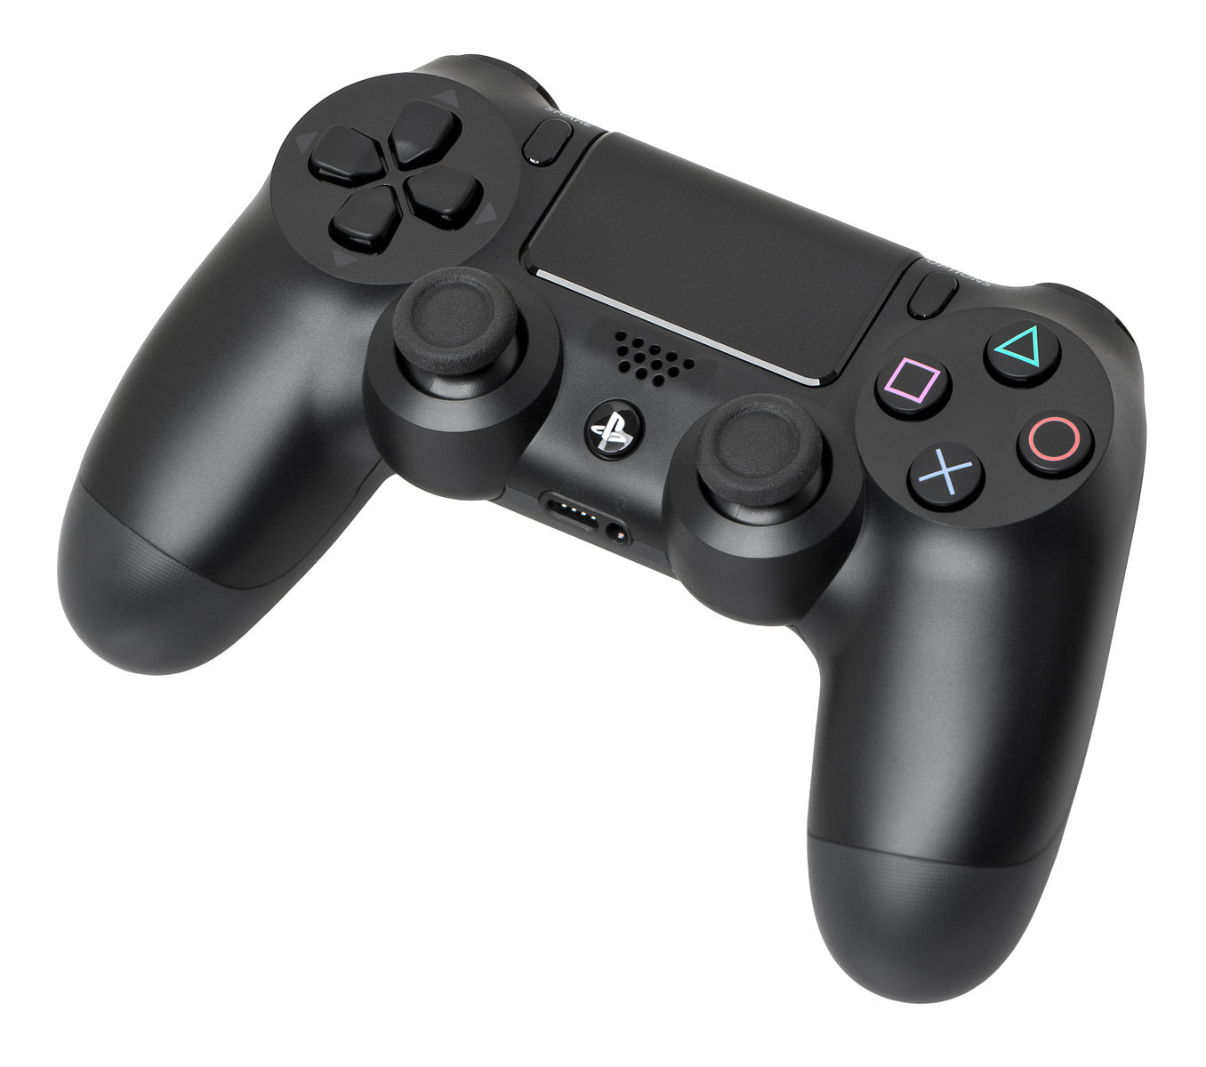
The PS4 controller has colored buttons (Amos, 2013).
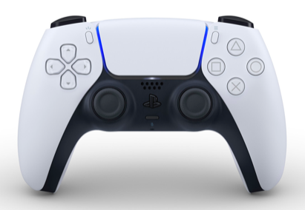
The PS5 controller lacks colored buttons (Sony, n.d.).
Figure 5.1c
Xbox One Controller
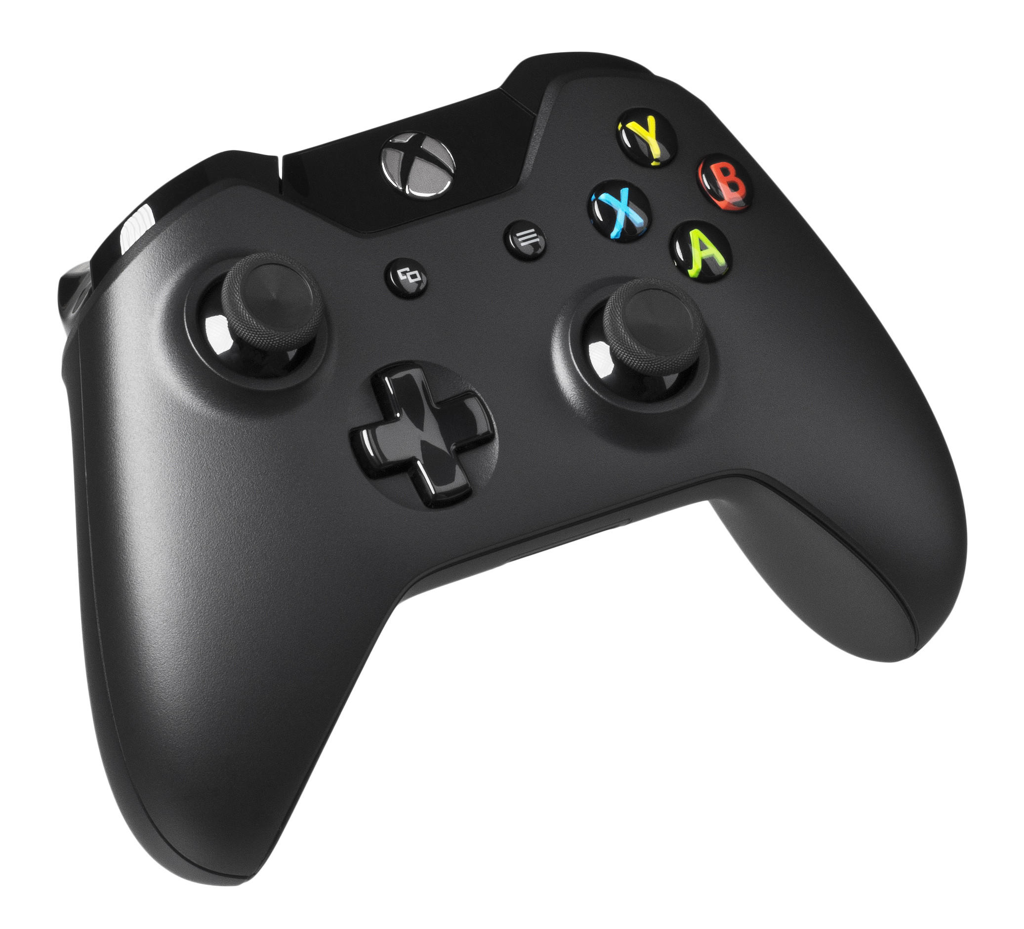
The Xbox One controller has colored letters (Amos, 2014).

5.2. Small Font and UI

5.2.1. The State of Font- and UI-Size in Games
Increasing numbers of games include accessibility options. The Last of Us Part II for the PlayStation 4 has been called “The most accessible game ever” (Saylor, 2020). This game offers HUD scaling and many other features. Other games that have accessible font- and UI-scaling are Monster Hunter World (e.g. Linnet’s How to, 2020), and Eve Online (e.g. CCP Games, 2017). For the Nintendo Switch, Animal Crossing does not include scaling options. However, the game has a comfortably large default size that is a stark contrast to a game like Fire Emblem: Three Houses, which has extremely small text.
Figure 5.2a
Font- and UI-Sizes of Fire Emblem: Three Houses and Animal Crossing
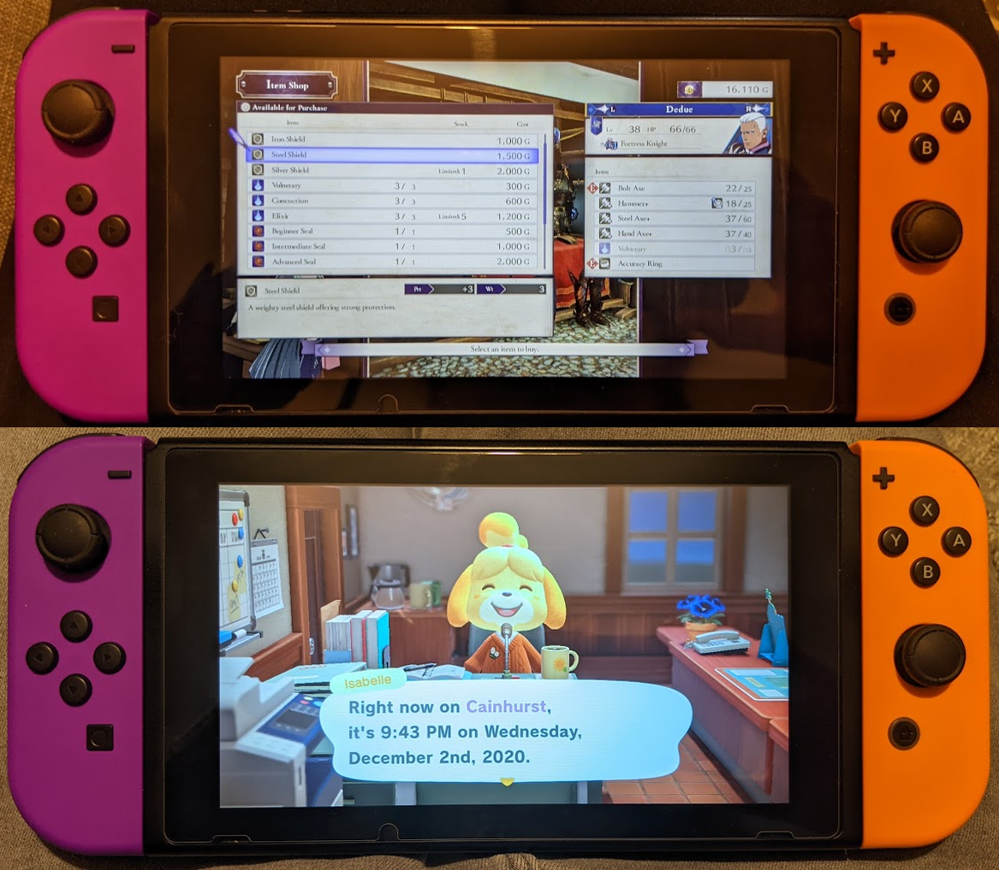
These photos of a Switch show the size difference between the respective fonts and UIs of Fire Emblem: Three Houses (first image) and Animal Crossing: New Horizons (second image).
Some games have options for font- and UI-scaling, but they are insufficient. The God of War team has released an update to allow font sizes to be increased. However, the change does not apply to all menus, and changing the setting barely increases the size (McWhertor, 2018).

Figure 5.2b
Font- and UI-Sizes of God of War
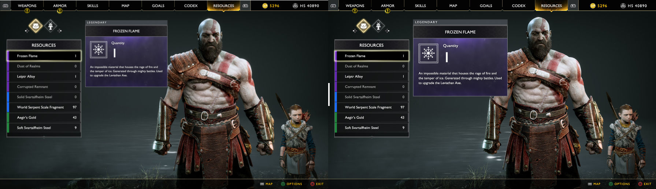
The first image shows the default size of the font and UI in God of War. The second image shows the largest possible size, which is slightly increased.

5.2.2. The State of Font- and UI-Size in Other Consoles
The PS4 has options to increase zoom-levels, increase font-size, and make text bold. However, the font-scaling option is a checkbox, which effectively offers a one-size-fits-all approach. This binary option might not help all users. The PS5 has a more flexible option to increase font-size, however it does not offer the flexibility of a slider (Craven, 2020).
The PS4 system menus have a text-to-speech function, which is a feature requested by one interview participants. This tool that would enhance the gaming experience for Switch players with low vision. This function is a next step that we examine in our design approach.
The Xbox One has no option to increase font-size; it only lets player zoom in to the screen (e.g. SophieTheCat, 2016). The Xbox Series X has a magnifier and a screen reader, but it has no option to increase the system font-size (HavokRose et al., 2020).

5.3. Filters

5.3.1. Filters in Other Media
Filters for digital displays are commonplace. They can be found for monitors and TVs under display settings (Figure 5.3a). By adjusting individual settings, users can change the way that TV visuals appear for them. Examples of options that can be changed are shown in Table 5.3 (Chaney, n.d.).

Table 5.3
Filter-Setting Values
Value | Definition
Contrast | Increases/decreases the difference between the dark and light parts of the image
Brightness | Increases/decreases how bright or light the image is
Saturation | Uniformly increases/decreases the difference between colors of the image by adding or removing color
Vibrancy | A smarter version of saturation that increases the saturation of more muted colors of the image.
Backlighting | Changes the amount of light that the display emits.
Sharpness | Increases/decreases the contrast along the edges of elements of the image

Alternatively, filters can also exist in the form of pre-sets, which are pre-defined color profiles that can be applied to the screen. An example is the macOS display settings (Figure 5.3a). Users have the ability to browse a list of predefined filters.
Figure 5.3a
Color Settings for a TV and a Computer

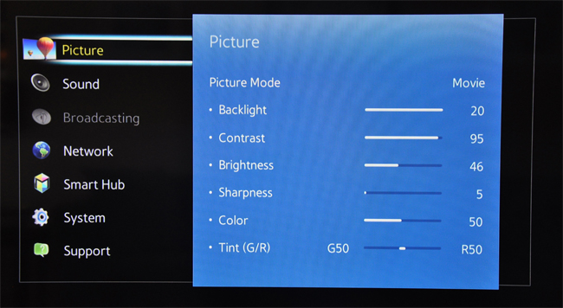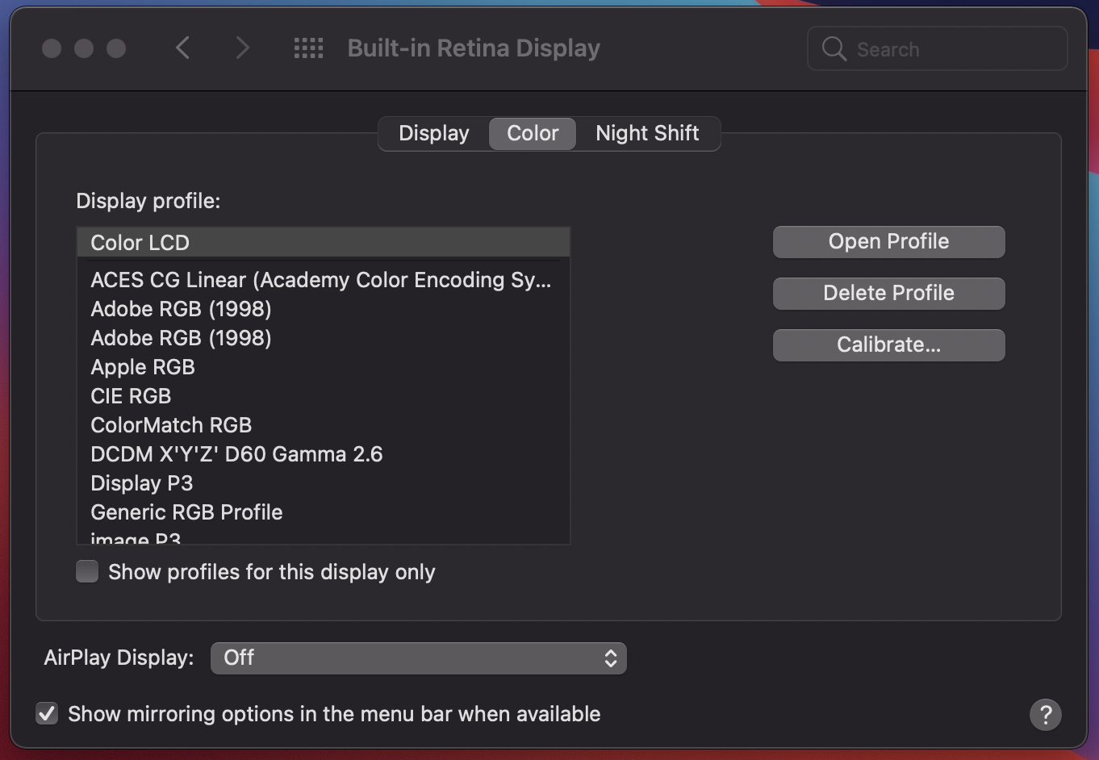
The first image shows freestyle settings for a TV (Gordon, 2017). The second image show color-profile presets for macOS.

5.3.2. Filters in video games
Accessibility in games has been a growing issue. While game systems can make settings and internal systems accessible, if the games are not accessible by default, the system cannot significantly improve them. Accessibility features must be created by game developers during the development phase. An example of a game developed with accessibility in mind is The Last of Us Part II. Figure 5.3b shows screenshots from The Last of Us and The Last of Us Part II. In the latter game, a high-contrast display mode was included as an accessibility feature. It would mute the background colors and convert characters to red or blue, depending on whether they were enemies (Brown, 2020). Superficial filters that are applied on top of game images cannot distinguish between layers and game elements in this way, so the best filters must be created while the game is still in development (Bryce Johnson, personal communication, November 5, 2020).
Figure 5.3b
Saturated-Color Modes in The Last of Us
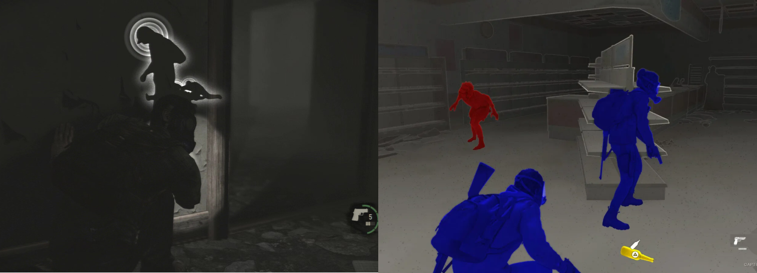
The first image shows poor visibility in The Last of Us. The second image shows the high-contrast mode of The Last of Us Part II. The latter clearly shows allies versus enemies (Brown, 2020).

6. Design Approach

6.1. General Design Approach
After conducting our cycle-of-exclusion exercise, we interviewed Bryce Johnson, the inclusive-design lead for Microsoft Devices. As an expert who has worked on the Xbox system, he provided us with a wealth of knowledge and ideas for next steps. His advice also helped us to narrow the three issues that we have previously outlined.
For each issue, we outlined our proposed solution in a Google Doc that we shared with target users for feedback and to test their efficacy. This document was given to Simon Barnett, an accessibility-technology teacher and two users from the sub-Reddit page, r/disabledgambers (Disabled Gamers, n.d.). Table 6.1 outlines the target users and their low-vision needs.

Table 6.1
Description of Usability-Test Participants
User | Low-Vision Issue | Has Nintendo Switch? | Low Vision Needs
P1 | Blind in one eye | Yes | Text is usually too small and the screen is not bright enough
P2 | Fully Blind | No
P3 | Oculocutaneous albinism and congenital cataract in left eye | Yes | Larger fonts, darker screens (sensitive to light)

6.2. Colored Buttons
Currently, all of the face buttons and directional buttons of the Nintendo Switch and Nintendo Switch Lite are the same color. It is very hard for people with visual impairment to distinguish these different buttons (e.g., Fulton, 2017). Also, because the Joy-Cons can be removed and held horizontally, it is even harder for an individual to find the correct button (D'Argenio, 2019). After meeting with Bryce Johnson (personal communication, November 5, 2020), our team decided to include colors on the buttons. We followed the Web Content Accessibility Guideline 1.4.1 and decided to combine letters with colors (World Wide Web Consortium, n.d.). We used Figma to make our prototype, and while designing, we did not rely only on colors to distinguish buttons on the controller. Initially, our team came up with two solutions: we devised colored buttons with dark text as our first proposed solution (Figure 6.2a and Figure 6.2b) and colored text and glyphs as our second proposed solution (Figure 6.2c and Figure 6.2d). We decided to use the color scheme of the Xbox controller. Thus, if the user is switching from any other game console’s controller to the Nintendo Switch, then they will not feel alienated.

Figure 6.2a
Nintendo Switch with Colored Buttons

Figure 6.2b
Nintendo Switch with Colored Text and Glyphs

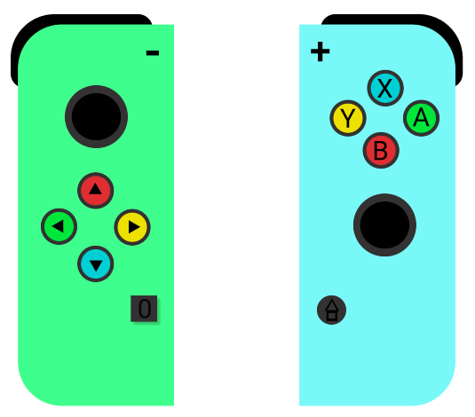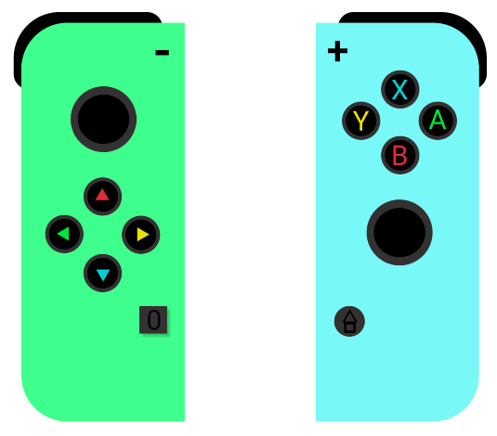

Figure 6.2c
Nintendo Switch Lite with Colored Buttons

Figure 6.2d
Nintendo Switch Lite with Colored Text and Glyphs

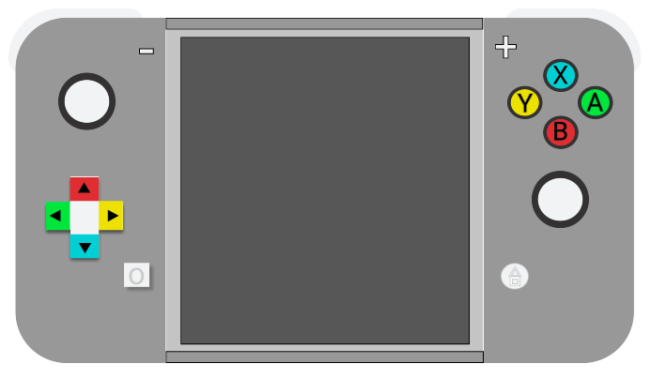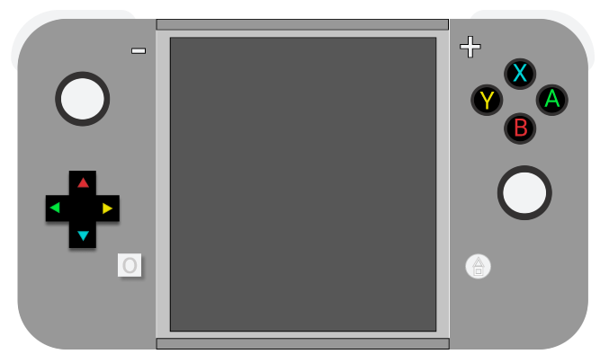

In November 2020, Hori released a controller/adapter called the Flex Controller (Figure 6.2e). After its release, our team had an informal chat with Simon Barnett (personal communication, November 25, 2020), a disability specialist and tech teacher. After discussing our colored-buttons idea with him, we decided to offer sticker-sheets along with the redesigned Nintendo Switch. Giving freedom to choose any colors for controller buttons would help a large range of users. This design choice will also benefit users with autism who find color inaccessible.

Figure 6.2e
Flex Controller for Nintendo Switch
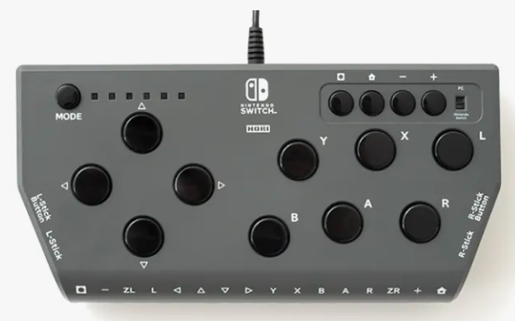
The Flex Controller is developed by Hori and officially licensed by Nintendo (Hori, n.d.).
One usability-testing participant, P2, suggested adding LED-backlight colors to the controller buttons. However, our team decided to exclude that idea because the cost involved with this enhancement would be passed to users.

6.3. Font Scaling
Because small text is prevalent within the games industry, and because the Switch does not currently have any system-level font- and UI-scaling options, we have progressed with our design for a percentage-based font- and UI-slider.

6.3.1. The Before and After for Our Design
Our initial Figma mockup featured five sizing options that were presented in pixel format (Figure 6.3a). To offer more flexible scaling options than the Xbox Series X and PS5, we have opted to use a slider that would allow to users to customize, down to the percentage, how large or small they want their font and UI to be (Figure 6.3b). In our interview with Bryce Johnson (personal communication, November 5, 2020), he confirmed that percentages would be more feasible than using pixel sizes, because the end result must be physically rendered on various screen sizes. For this reason, we believe that percentage-scaling would work best.
Figure 6.3a
Font-Scaling Represented as Pixels
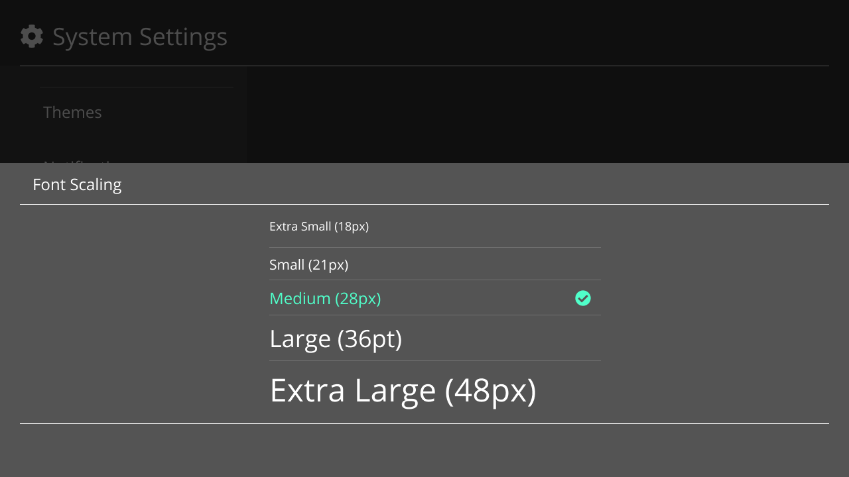
Our first attempt at introducing font-scaling was pixel-based. Five options were conceptualized. The default option had a comfortable size of 28px, recommended by Game Accessibility Guidelines (n.d.-c).
Figure 6.3b
Font-Scaling Represented as Percentages
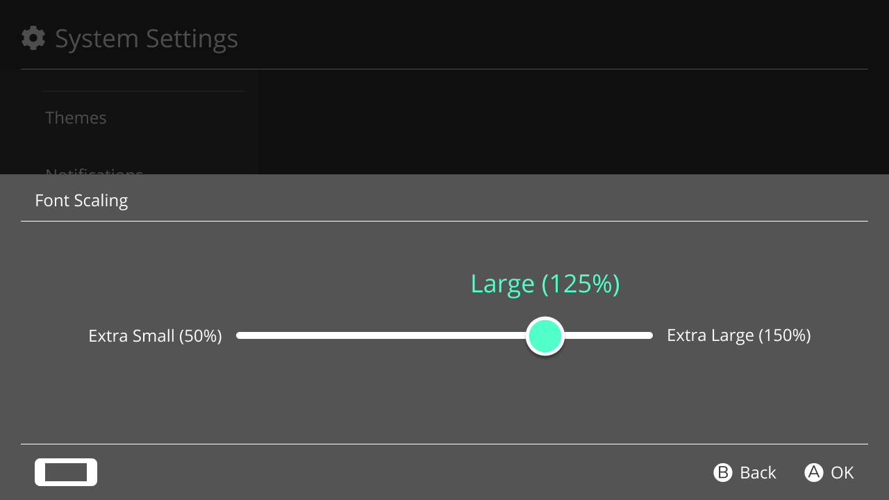
A mockup of our revised font- and UI-scaling slider, which allows the user to increase or decrease the size of all fonts and UI at a system level. It does not affect font and UI sizing in games.

6.3.2. The Case for Flexible Scaling
Bryce Johnson has stated in our interview that “designers are apprehensive about covering up too much of the gameplay, even if their users want it” (personal communication, November 5, 2020). This tendency has pushed us to include flexible scaling in our design, because we want to place accessibility over the potential aesthetic downsides of having larger UIs. By using an adjustable scale, users with full vision who want an unobtrusive UI will still be able to reduce its size. In contrast to the effects of font scaling seen in games like God of War, any changes to font- and UI-size will cascade throughout all Switch menus and widgets. In accordance with the WCAG principle of re-flow (World Wide Web Consortium, 2018), re-sized content will also adjust according to content around it to maintain consistency with its surroundings (see Figure 6.3c).
Figure 6.3c
Example of Font-Scaling and Content Re-Flow

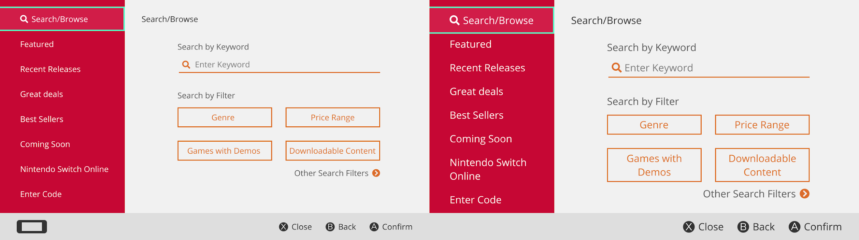
The first image is the default size of the Switch eShop menu with a Medium (100%) font size. The second image is an adjusted Large (125%) font size (right) that demonstrates content re-flow.
Our flexible-scaling design is also based on three principles provided by the Game Accessibility Guidelines website, which were based on input from disabled gamers (see Table 3).
Table 6.3
Design Guidelines for Fonts in Video Games
Guideline 1 | Guideline 2 | Guideline 3
Allow interfaces to be resized (Game Accessibility Guidelines, n.d.-a). | Allow font size to be adjusted (Game Accessibility Guidelines, n.d.-b). | Use an easily readable default font size. (Game Accessibility Guidelines, n.d.-c).

Ideally, our solution would also affect the font- and UI-sizes of games themselves. However, as Bryce Johnson has explained, this universal scope is not technically feasible with current technology. Thus, our design is limited to the system menus. We hope that game developers will take notice, and use the presence of font- and UI-scaling in the system as inspiration to include it in their Switch games.

6.4. Screen Filters
Narrowing our scope to low-vision gamers helped us to narrow the kinds of filters that we developed. Instead of colors for color-blind users, we decided to focus on improving visuals for low-vision users. Bryce Johnson’s main recommendations for filters involved three main ideas: focus on how to make filters accessible during mid-play, create pre-sets for different types of games, and finally, look at saturation and vibrancy as settings for filters (B. Johnson, personal communication, November 5, 2020).

6.4.1. Exploring Pre-sets
We started this process by trying to understand how different types of games might appear to people with different types of low-vision. For example, adventure games tend to be brighter and horror games tend to be darker. We looked at screenshots of Animal Crossing: New Horizon (social simulation), Amnesia: The Dark Descent (horror), Diablo III (hack-and-slash), Legend of Zelda: Breath of the Wild (adventure), This War of Mine (survival), and The Outer Worlds (action / role-playing game).
Additionally, we have used the No-Coffee Vision Simulator to empathize and understand how gamers with different low-vision needs actually view these different games. We considered diabetic retinopathy, cataracts, and low-contrast vision users as seen in Figure 6.4a.
Figure 6.4a
Simulations of Vision Impairments with Various Games

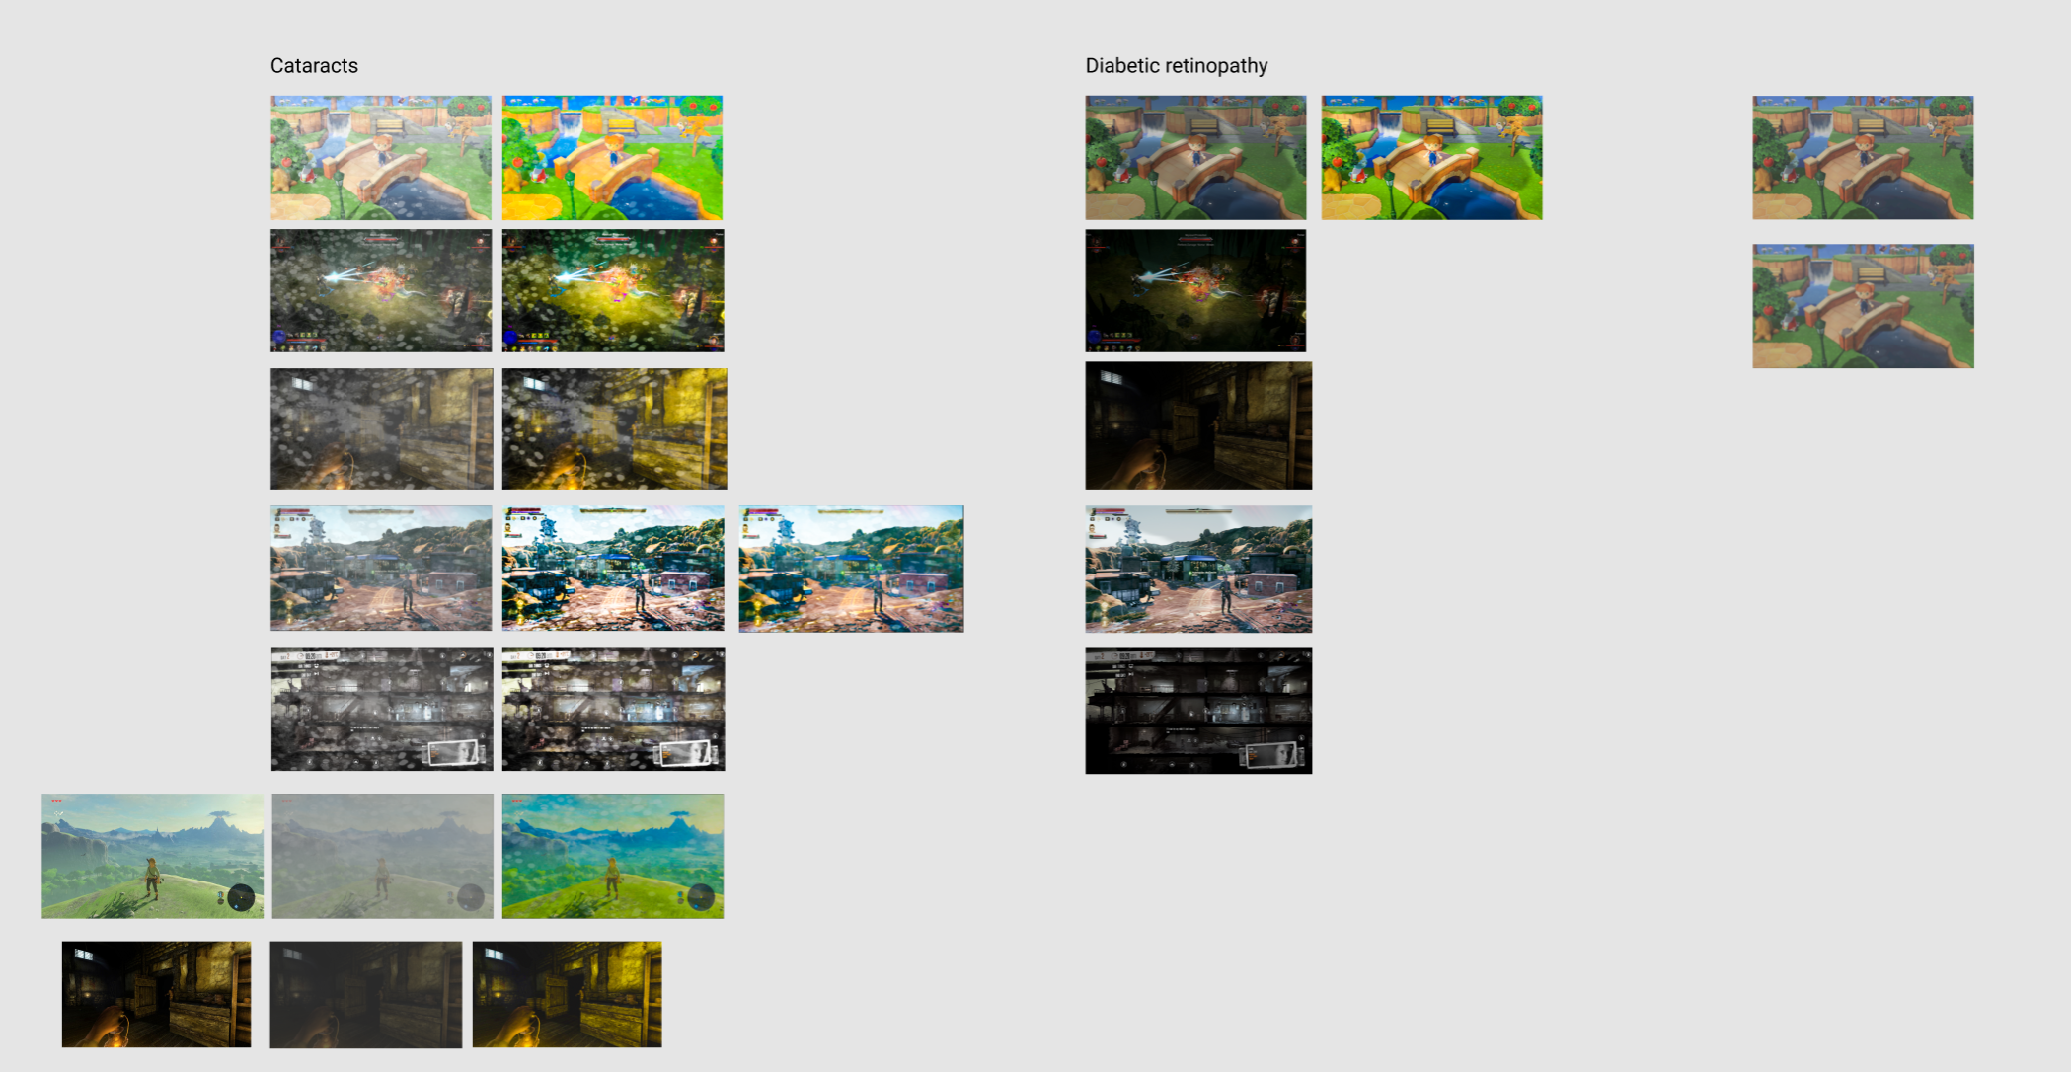
This collection of screenshots is the previously mentioned games. They show different low-vision issues and potential fixes.
After viewing each screenshot with different visual simulations, we edited the images in Adobe Lightroom by adjusting brightness, contrast, sharpness, vibrancy, and saturation. We ended up with three basic pre-sets where at least one improved visibility for all of the aforementioned games, which can be found in Appendix A.

6.4.2. Creating a Prototype
Once we had an idea of which kinds of pre-sets might help, we created a prototype in Figma. Taking Bryce Johnson’s feedback, we looked for ways to make the pre-sets available in-game. By making pre-sets available in-game, it is easier to play the game in a meaningful way: time-sensitive actions that require being able to see the game can be made in time.
The Switch already has an in-game menu that can be opened by holding the Home button, which is located at the bottom of the right-hand Joy-Con. This menu contains settings for brightness, volume, and Wi-Fi access. We decided to place the proposed filters in this menu and keep the mechanism for navigating the menu (i.e. right-hand joystick, A Button to accept, and B Button to cancel). This scheme will ensure easy adoption and intuitive access, because we are keeping systems that are familiar to users. The Switch menu has no explicit function to save settings. Instead, adjusting an option effectively ‘saves’ the setting, and then users can exit the menu. We have decided to keep this functionality so when users use the joystick to navigate to a filter, it will automatically be applied, and they can simply exit the menu. For the prototype, users can open the menu by pressing Enter on their keyboard. They can then use the arrow keys to navigate and then press Enter to select. We only created parts of the prototype so usability testers had an idea of what it would look like.
From here, we came up with three slightly different ways of displaying pre-sets.
A. Users select pre-defined filters
This solution provides only a set of filters that the user can choose from (Figure 6.4b). The idea is to reduce cognitive load and let users pick from a consistent set of pre-sets. This model follows how macOS offers pre-set filters for connected displays, as described in the research section.
Figure 6.4b
Selecting a Pre-defined Filter
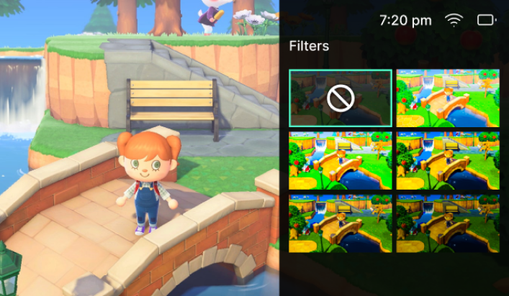
This screenshot shows a hypothetical selection of pre-defined filter sets.
B. Users create filters
This solution allows users to create their own pre-sets and save them by adjusting settings like brightness, contrast, saturation, vibrancy and sharpness (Figure 6.4c). This model follows closely with how monitors and TVs allow users to edit color profiles, as described in section 5.3 of this report.
Figure 6.4c
Creating a Filter
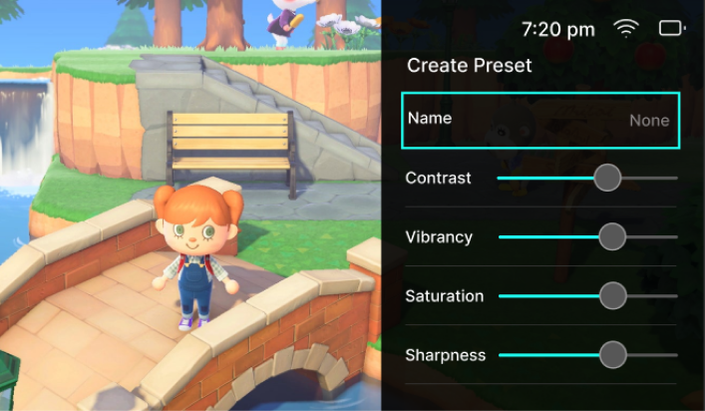
This screenshot shows hypothetical creation of a custom filter.

C. Users select pre-defined filters, edit pre-defined filters, and/or create their filters
Finally, this solution combines the previous two options by offering pre-sets, allowing users to create filters, and copy and edit the settings of existing filters to create new ones (Figure 6.4d). The user can use the joystick to navigate to a filter, where they can press Y to copy and start editing the pre-set.
Figure 6.4d
Copying a Pre-defined Filter
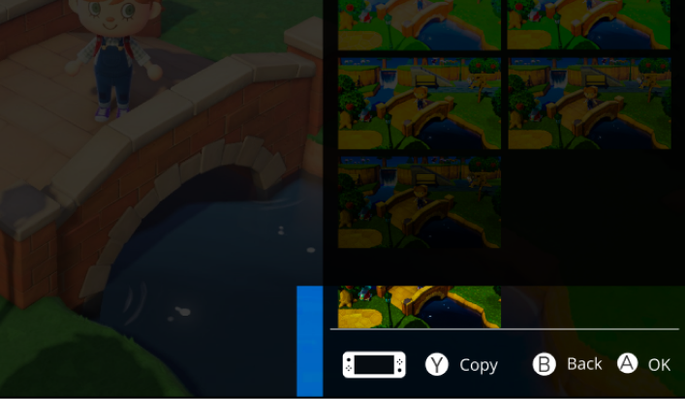
This screenshot shows pre-defined filters with the ability to create more or edit existing ones.
These options were presented to participants who were outlined in section 6.1 of this report. They were asked for their feedback.

7. Evaluation

7.1. Colored Buttons
We tested our proposed solutions with a few participants. After getting feedback from them, we decided to go with our second solution, which was colored letters on the buttons (Figure 7.1a and Figure 7.1b). Colored letters would not be overwhelming for visually impaired users compared to colored buttons. We even incorporated the participants' idea to raise the letters instead of engraving the letters so that users can feel which button they are pressing without looking at the controller.

Figure 7.1a
Nintendo Switch Joy-Cons with Raised and Colored Letters and Glyphs
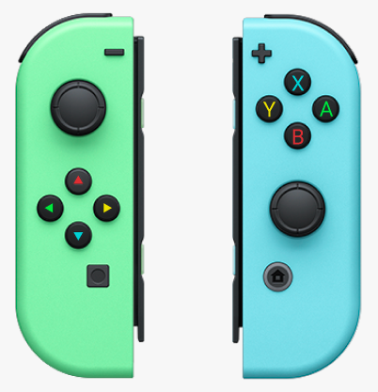
Figure 7.1b
Nintendo Switch Lite with Raised and Colored Letters and Glyphs

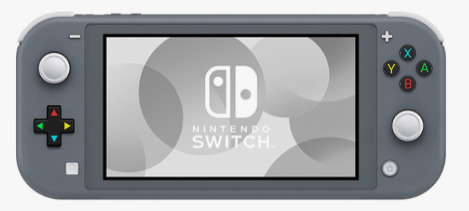

7.2. Small Font and Small UI

7.2.1. Confirming Our Assumptions
All feedback provided by participants confirmed that including font-scaling as a system setting in the Nintendo Switch menus would be a good idea. We were not able to determine if the specific size that we identified would help to reduce eye-strain and discomfort. However, we would determine the ideal size in our next steps. P3 stated the following: "I really want text-scaling and I'm used to seeing it in the display setting of iOS, but it could also be a separate Accessibility menu" (P3, personal communication, November 24, 2020). This comment aligns with our initial concept of including the font- and UI-scaling feature in a new Display menu (Figure 7.2a).
Figure 7.2a
Display Menu with Visual-Accessibility Settings
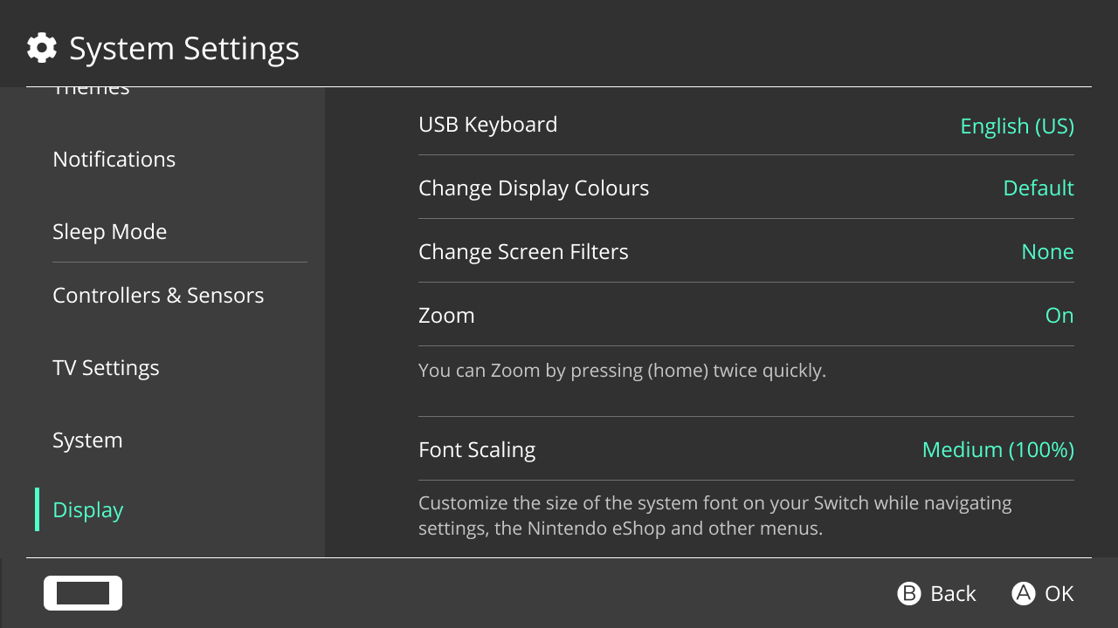
This mockup shows a Display menu, where we have grouped existing and proposed display-settings. This menu includes the existing Zoom feature as well as our new Screen Filters and Font Scaling settings.
As previously mentioned, Bryce Johnson (personal communication, November 5, 2020) explained to us that percentage-based scaling would be helpful and feasible. This advice led us to maintain this method of presenting and scaling font and UI, rather than using pixel-values.

7.2.2. A Future Design to Evaluate: Text-To-Speech
We did not get much feedback that changed our initial design for font- and UI-scaling. However, our conversation with P3 has revealed a need for a text-to-speech feature. "Many users would really want text-to-speech for the Switch UI as well. I'm happier with larger text" (P3, personal communication, November 24, 2020). In addition to font- and UI-scaling, according to this participant, users with low-vision would appreciate having text and UI elements read to them. The recent Xbox and PlayStation consoles have this feature, yet the Switch lacks it. Nintendo would benefit from this change by removing barriers for low-vision users and staying competitive in the market. While we do not have time to validate this design, we did create a mockup that explores the concept (Figure 7.2b).
Figure 7.2b
Text-to-Speech Setting
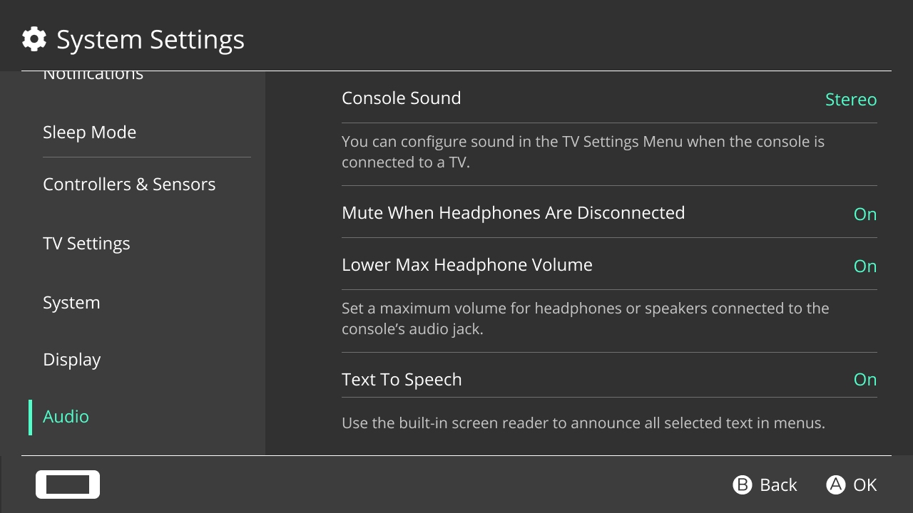
This mockup shows where a new text-to-speech function could exist within the Switch menus. All existing sound-related options have been moved to a new Audio menu to make them easier to find. This design has not been shown to users, but it is based on user feedback.

7.3. Filters
Feedback from Simon, P1, P2, P3 were unanimous. They all favored the option of having pre-set filters that they could edit and duplicate. P3 felt that having existing pre-sets would provide a base that they could tweak (Figure 7.3a). It also meant that users would have an example of a given setting’s outcome. P3 also mentioned wanting section-labels for organizing purposes.

Figure 7.3a
Revised Menu for Filters
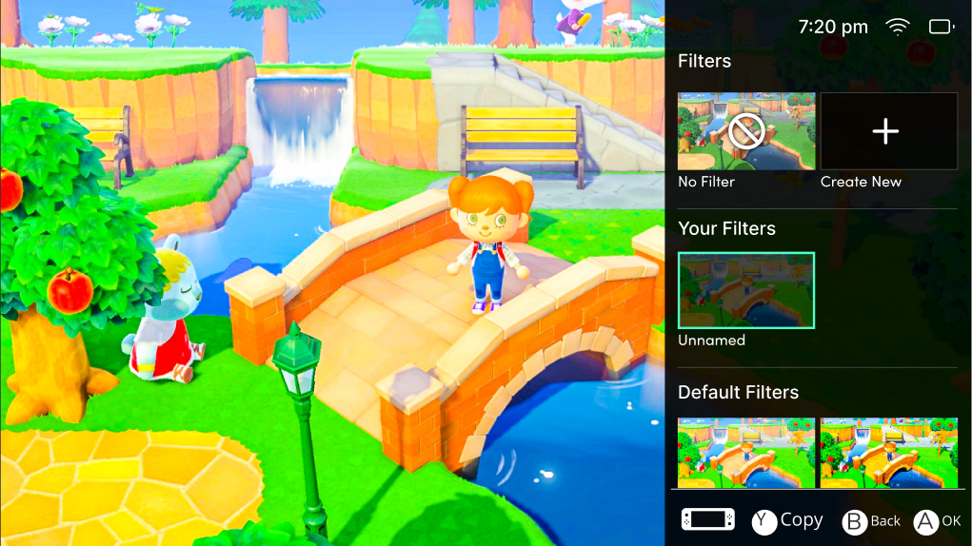
This screenshot shows the final filter menu. A link to the prototype can be found in Appendix B.

8. Reflections
This project has made us appreciate ‘the power of one.’ Insight from one person, whether they are a target user or a subject-matter expert, can drastically change a project for the better. ‘Strength in numbers’ is the underlying philosophy in typical user-research, but for helping under-represented groups, one member can be more than enough to reveal barriers that might be overlooked. For this project, we have better understanding of barriers for low-vision people who play video games. We have not developed a solution to compensate for color-blindness, but our secondary research has revealed that color-blind modes in games merely simulate types of color-vision deficiencies instead of accommodating them (e.g. razorbeams, 2018). Had the developers of these games managed to test their color-blind modes with one target user, they would have recognized their folly.
The ‘power of one’ was apparent in our personal communication with experts and users alike. Bryce Johnson (personal communication, November 5, 2020) gave feedback that helped us pivot to developing more pragmatic solutions that could be realized much sooner. He provided insight into the relationship of scope between system software and game software. Some of us intuitively sensed this relationship, but confirmation from an expert was valuable. Simon Barnett (personal communication, November 26, 2020), among other things, gave us inspiration for the practical idea of offering different palettes (i.e. color sets) for colored buttons. He explained that some users with cognitive impairments would prefer buttons with uniform colors. The users P1, P2, and P3 gave feedback that helped improve our prototypes and validate our solution ideas. These ideas included some that we had excluded from our narrowed focus, such as text-to-speech functionality.

9. Conclusions & Next Steps

9.1. What We Did
The following outline summarizes our process.
- Conducted secondary research using various sources
- Design guidelines developed by gaming-accessibility movement (i.e. Game Accessibility Guidelines)
- WCAG developed by W3C
- Academic papers about related topics
- First-hand experience as gamers
- Developed solutions for five issues;later selected issues from secondary research
- Guidelines based on existing practices and would ideally become standards
- Presented solutions to Bryce Johnson, industry expert
- Learned about inherent limitations of software architecture
- Received feedback about feasibility and plausibility of existing solutions
- Developed prototypes and mockups for three issues (colored buttons, font- and UI-scaling, screen filters)
- Did more secondary research
- Prototypes would be implemented in hardware or system software
- Prior design guidelines (except modified buttons) would have been implemented at game-level
- Presented prototypes to people with first- or second-hand experience
- P2 validated prototypes, suggested improvements, and noted other issues
- P3 validated certain decisions and explained needs
- Simon Barnett, special-needs educator, noted an important design-philosophy
- Gathered user stories throughout project
- Created and followed discussions on GameFAQs and Reddit
- Gained insight into range of impairments, issues, and contexts
- Provided validation of solutions, ideas for self-evaluation

9.2. What We Wish We Did
Initially, we aimed to create a set of Switch-focused guidelines and standards that game studios would follow. These system-level and game-level features and options would benefit blind and low-vision players. The notion of colored buttons has been our only hardware-based solution.
However, based on Bryce Johnson’s feedback and guidance, we pivoted to more intermediate and pragmatic solutions. Instead of game-level features that might be a few to several years from widespread implementation, we have developed two system-level solutions that address some of the identified issues. They are narrower in scope, but they could be implemented more immediately. The colored buttons solution has been the only constant throughout the project.
In addition to our existing solutions, we wish that we could have further developed guidelines and standards for game studios. We also wish that we had time, funding, and expertise to create interactive prototypes and then test them with representative users.

9.3. Next Steps
In the immediate future, we would do more user-testing and then prototyping. We would seek feedback from more low-vision players because they could further validate our solutions, identify things to improve, or both. Next, we would produce interactive prototypes. However, funding and additional expertise would be needed for producing prototypes of colored buttons. Beyond user-testing and prototyping, we would address the issues and consequences that would result from our solutions. Some of these areas are not necessarily within the scope of our responsibility, but we would make recommendations, nonetheless.
Firstly, colored buttons would need to be manufactured and distributed. As a result, this solution would inevitably create barriers to access for some people because of financial, geographic, and/or logistical factors. We would recommend that Nintendo produce colored covers or stickers instead of new controllers with colored buttons. The former would be cheaper to make and buy as well as easier to ship and receive.
Secondly, font-scaling would not reliably apply to games. We would recommend that (if feasible) Nintendo and game studios make the implementation of system-level, font-scaling compatible with game-level text. Otherwise, we would recommend a set of standard (relative) font sizes; Nintendo would then require game studios to include these sizes in their games. We could further explore our design for a system-level, text-to-speech feature, or even make the technology available to game studios, as Bryce Johnson suggested.
Thirdly, screen filters could cause issues in local-multiplayer games, especially in shared-screen modes. We would recommend that (if feasible) Nintendo make screen filters specific to controller/player profiles so they can be independently selected and displayed. Otherwise, we would recommend a set of game-level filters or options that Nintendo would require game studios to include in their games.

Fourthly, screen filters, specifically the pre-sets, would need to be validated with low-vision players. This validation is important to ensure filters accommodate players with certain vision impairments instead of merely simulating those vision impairments.

References
Amos, E. (2013). DualShock 4.jpg [Photo]. Wikimedia Commons. https://commons.wikimedia.org/wiki/File:DualShock_4.jpg
Amos, E. (2014). Microsoft-Xbox-One-controller.jpg [Photo]. Wikimedia Commons. https://commons.wikimedia.org/wiki/File:Microsoft-Xbox-One-controller.jpg
Brown, S. (2020, June 12). The Last of Us Part 2 gives players with disabilities a better gaming experience. CNet. https://www.cnet.com/tech/computing/the-last-of-us-part-2-gives-players-with-disabilities-a-better-gaming-experience/
CCP Games. (2017, October 23). User interface (UI) scaling / Text font size increase. Eve Help Center. https://support.eveonline.com/hc/en-us/articles/115005458149-User-Interface-UI-Scaling-Text-Font-Size-Increase
Chaney, M. (n.d.). Brightness, contrast, saturation, and sharpness. Steve’s Digicams. http://www.steves-digicams.com/knowledge-center/brightness-contrast-saturation-and-sharpness.html#b
Craven, C. (2020, November 18). Xbox Series X: The accessibility review. IGN. https://sea.ign.com/feature/166171/xbox-series-x-accessibility-review
D’Argenio, A. M. (2019, August 14). Just fix your controller layout already – A history of... where the heck is the X button? https://gamecrate.com/just-fix-your-controller-layout-already-history-where-heck-x-button/23875
Disabled Gamers. (n.d.). [Online forum]. Reddit. https://www.reddit.com/r/disabledgamers/
Frictional Games. (n.d.). amnesia-the-dark-descent-grunt-doorway.jpg [Screenshot]. iMore. https://www.imore.com/sites/imore.com/files/styles/large/public/field/image/2019/09/amnesia-the-dark-descent-grunt-doorway.jpg
Fulton, G. (2017, December 3). Accessibility basics: Designing for visual impairment. Envato Tuts. https://webdesign.tutsplus.com/articles/accessibility-basics-designing-for-visual-impairment--cms-27634
Game Accessibility Guidelines. (n.d.-a). Allow interfaces to be resized. http://gameaccessibilityguidelines.com/allow-interfaces-to-be-resized/
Game Accessibility Guidelines. (n.d.-b). Allow the font size to be adjusted. http://gameaccessibilityguidelines.com/allow-the-font-size-to-be-adjusted/
Game Accessibility Guidelines. (n.d.-c). Use an easily readable default font size. http://gameaccessibilityguidelines.com/use-an-easily-readable-default-font-size/
Gordon, W. (2017, November 9). How to get the best picture quality from tour HDTV. How-To Geek. https://www.howtogeek.com/299838/how-to-get-the-best-picture-quality-from-your-hdtv/
Gratis, T. (2017). 882331-the-legend-of-zelda-breath-of-the-wild-nintendo-switch-screenshot.jpg [Screenshot]. Moby Games. https://www.mobygames.com/game/switch/legend-of-zelda-breath-of-the-wild/screenshots/gameShotId,882331/
HavokRose, Ragga_Fragga, JanetG314, Jitrel, Samuel-IGN, Feliciavagabond, Zenayru, & Antonov88. (2020). All Xbox Series X settings. In Xbox Series X Wiki Guide. IGN. https://www.ign.com/wikis/xbox-series-x/All_Xbox_Series_X_Settings
Hori. (n.d.). Flex-Controller_web_015_700x__18041.1624574329.png [Photo]. Hori. https://cdn11.bigcommerce.com/s-bsuqqx/images/stencil/1280x1280/products/834/2534/Flex-Controller_web_015_700x__18041.1624574329.png?
Huynh, T. [J S. (2020, October 29). Gamers with impaired vision [Online forum post]. GameFAQS. https://gamefaqs.gamespot.com/boards/189706-nintendo-switch/79072426
Linnet’s How To. (2020, April 3). How to change help text size Monster Hunter World [Video]. YouTube. https://youtu.be/ucVwh1NxEkA
McWhertor, M. (2018, April 23). God of War update makes the game’s tiny text easier to read. Polygon. https://www.polygon.com/2018/4/23/17270208/god-of-war-ps4-update-text-size-font-update
Naughty Dog. (2020). The Last of Us Part II [Video game]. Sony Interactive Entertainment.
Nintendo. (n.d.). About Nintendo. https://www.nintendo.com/about/
Patterson, A. (2020, November 10). PS5 designer explains why the controller’s buttons lost their trademark colors. CBR. https://www.cbr.com/ps5-designer-explains-why-the-controllers-buttons-lost-their-trademark-colors/
razorbeams. (2018, July 16). Why do so many games’ colourblind modes simulate colourblindness instead of being a true accessibility mode? [Online forum post]. Reddit. https://www.reddit.com/r/colourBlind/comments/8zbv74/why_do_so_many_games_colourblind_modes_simulate/
Saylor, S. (2020, June 12). The Last Of Us Part II - Most accessible game ever! - Accessibility impressions [Video]. YouTube. https://youtu.be/PWJhxsZb81U
Saylor, S. [@stevesaylor]. (2019, September 16). Here’s a list of AAA games with small text released in 2019 and have no options to increase size [Tweet]. Twitter. https://twitter.com/stevesaylor/status/1173589801834094592
Sony. (n.d.). [Photo]. PlayStation.com.
SophieTheCat. (2016, January 16). Is there anyway to increase the font size of the text? [Online forum post]. Reddit. https://www.reddit.com/r/xboxone/comments/41anym/is_there_anyway_to_increase_the_font_size_of_the/
Thompson, C. [@cherryrae]. (2018, October 15). 1: there’s subtitle size and a background opacity slider! Take note, tho: on the Switch the large subtitle size is [Tweet]. Twitter. https://twitter.com/cherryrae/status/1051889225807749121
World Wide Web Consortium. (n.d.). Understanding Success Criterion 1.4.1: Use of Color. W3. https://www.w3.org/WAI/WCAG21/Understanding/use-of-color.html
World Wide Web Consortium. (2018, June 5). Web content accessibility guidelines (WCAG) 2.1. W3. https://www.w3.org/TR/WCAG21/#reflow

Appendices

Appendix A
Figure 1
Simulated View of Diabetic Retinopathy and Typical View
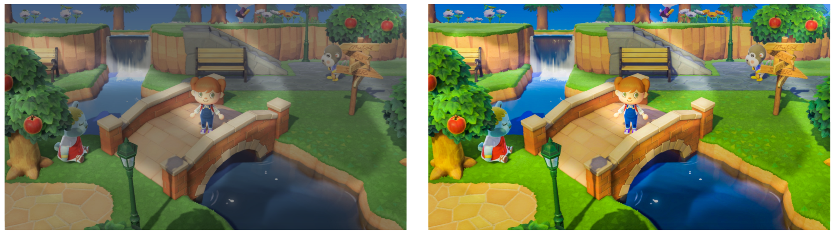
The first image simulates the view of someone who has diabetic retinopathy while playing Animal Crossing.
Figure 2
Simulated View of Cataracts and Typical View
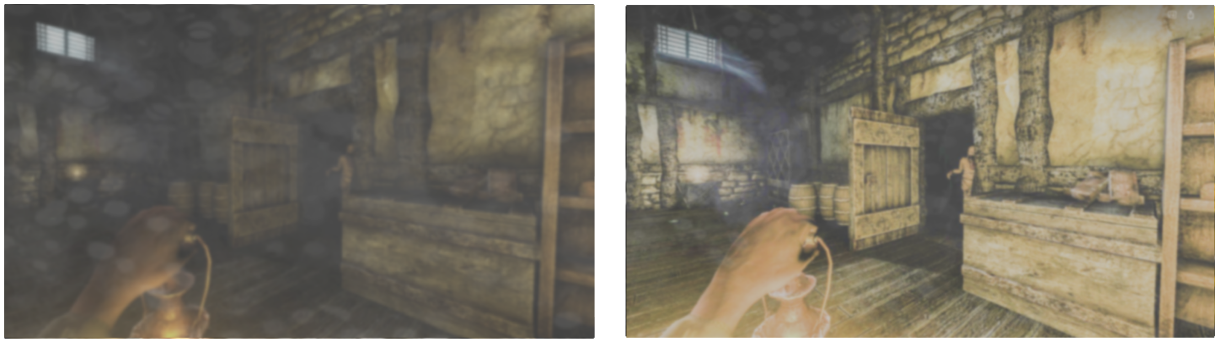
The first image simulates the view of someone who has cataracts while playing Amnesia: The Dark Descent.
Figure 3
Simulated Views of Diabetic Retinopathy
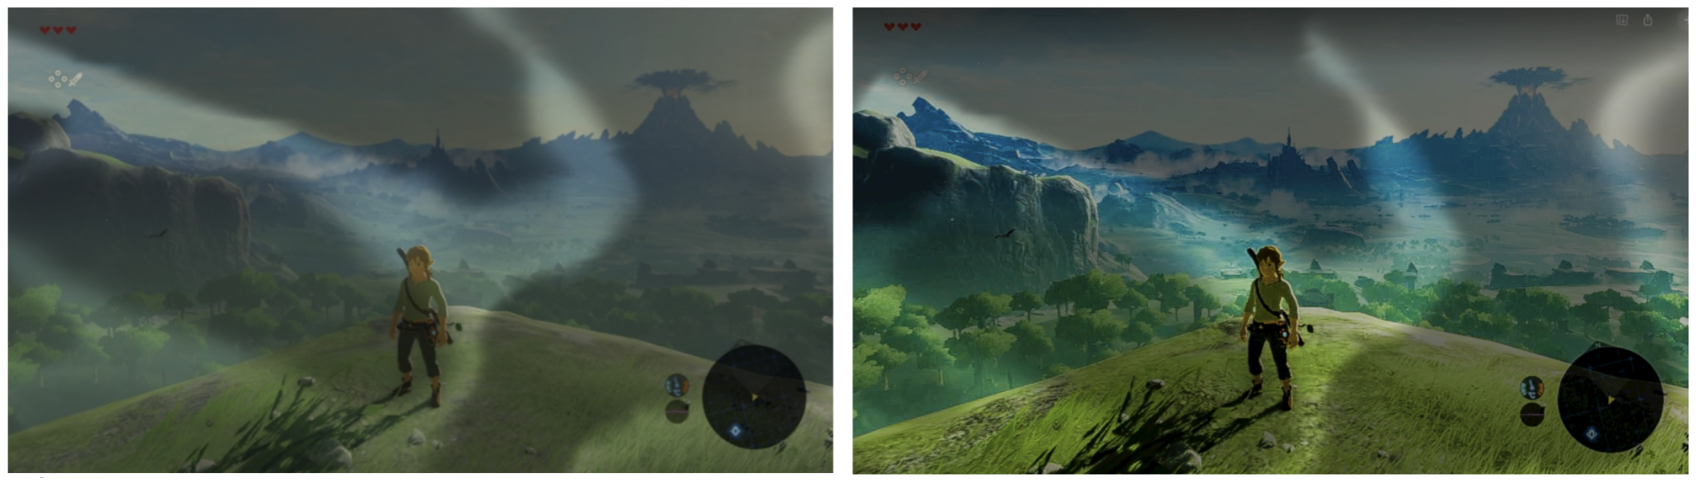
These images simulate the views of someone who has diabetic retinopathy while playing The Legend of Zelda: Breath of the Wild.

Appendix B
The final prototype for the filters: https://www.figma.com/proto/XTYHY3jSxq6kee2y9hkZiw/Nintendo-Switch?node-id=27%3A2&viewport=249%2C-910%2C0.09515967220067978&scaling=contain

