Design Challenge Proposal: The Nintendo Switch

Accessibility and Inclusive Design

Tim Huynh
Laura K
Swakirti S
Tammy T
Siqing Z

1. The Product
We are proposing a redesign for the Nintendo Switch gaming console. We will focus on barriers that players face when using the Switch controllers, the system menus, and while playing games such as Animal Crossing. We will discuss barriers that gamers with disabilities face when playing other consoles, because many of the same barriers apply to the Switch.
As of this report, the only accessibility settings that the Switch contains in its menus are controller remapping, a zoom feature, color inversion, and grayscale settings.

2. The Users
For this proposal, we are focused on users with visual impairments (VI) and users with hearing loss. Appendix 1 lists people whom we have researched in the gaming community.
According to the World Health Organization, at least 1 billion people have a vision impairment, including low vision, color-blindness, cataracts, partial blindness, and total blindness (World Health Organization, 2021a). Additionally, over 5% of the world’s population, or 466 million people, has disabling hearing-loss (432 million adults and 34 million children). It is estimated that by 2050 over 900 million people, or one in every ten people, will have disabling hearing-loss (World Health Organization, 2021b).

3. Barriers and Proposed Solutions
We have identified the proposed barriers that these users might face and several solutions that can reduce these barriers.
Barriers | Proposed Solutions
Text and UI on the Switch in handheld- and docked-modes are too small and cause eye-strain. | Introduce a comfortable default text-size as well as flexible font- and UI-scaling to make interface elements are easy to perceive.
The physical buttons on the Switch are all the same color and have low contrast between the letters/glyphs and background. | Introduce solid colors and higher-contrasting letters for the buttons.
The Switch lacks a robust, text-to-speech feature. Games have a lot of textual, non-dialogue information that is important, yet it is difficult to see. | Narrate menus and important in-game information. Provide audio cues, whether sounds or speech, for useful information that changes often. Make game information available on accessible web sites.
A lack of color choices and settings brings difficulty for people with color-blindness and/or low color-contrast sensitivity. | Provide customized color schemes for different types of color-blindness. Allow users to increase the color contrast between the foreground and the background.
Switch lacks the directional accessibility feature that would guide the user throughout the game. Currently, deaf and visually impaired users are directionless and are missing the full experience of games. | Adding readable subtitles and closed captions, visual and audio clues, and vibration on the controller can help the player know which direction they need to follow.

3.1. Small Fonts and Small UI

3.1.1. The Barrier
According to gamers with VI, the games industry has an issue with the constant use of small text and small UI-elements. This same barrier exists on the Switch. It is worse in the console’s handheld mode because the text and UI are even smaller compared to its TV-connected, docked mode. The Switch has a zoom feature in the settings menu, but it lacks font- or UI-scaling. An article from Can I Play That reveals that many games ported from other consoles to the Switch also face this issue, because they were not initially designed to be played on such a small screen (Bayliss, 2020).
Gamers with VI face physical discomfort when trying to read small text, or they cannot perceive UI and text at all. Steve Saylor, a blind gamer and game-accessibility advocate, provided a list of seven AAA games released in 2019 that offered tiny text with no option to resize it. Expanding on this list, he wrote “I am sick and tired of having to get excited for games only to be unplayable because of font size!” (Saylor, 2019). Steve is not the only blind gamer who has identified the problem with tiny interface-elements. In a tweet about the Switch game Starlink: Battle for Atlas (Ubisoft Toronto, 2018), Cherry Thompson (2018) comments that they experience eye strain, especially in the Switch’s handheld mode because the UI text is so small.

3.1.2. The Solution
The solution to this barrier is a setting in the Switch’s system menu that allows for graceful font- and UI-scaling. This setting would affect the console itself and Switch games. It would introduce two sliders representing text and UI that start at a readable, default size. This default size would be “Medium,” and text would be 28px on a 1080p screen. To provide the player with extra flexibility to fit their needs, they can also independently shift both sliders to be Small, Extra Small, Large, or Extra Large.

3.1.3. The Research
In an episode of Steve Saylor’s podcast Access Granted, Ian Hamilton, an accessibility specialist, explains that flexible text-scaling is necessary for game developers to cater to players who need accessible text and players who want an unobtrusive interface (Hamilton, 2020). Ian suggests that the web standard of responsive design—where text adapts to the screen size being used—can inspire the games industry.
According to the Game Accessibility Guidelines website, the barrier of tiny text can be reduced by using a default size that is large and readable (Game Accessibility Guidelines, n.d.-c), offering different size options (Game Accessibility Guidelines, n.d.-b), and allowing UI to be rescaled to meet the particular needs of players (Game Accessibility Guidelines, n.d.-a).

3.1.4. Reducing Barriers
By introducing a font- and UI-scaling mechanism, gamers who have VI will not be forced to experience eye-strain and discomfort from focusing on small text and UI on the screen. They will be able to read text and UI that would otherwise be too small or blurry to see, and in certain cases, they might not need to sit as close to the screen when playing.

3.2. Uniform Labelling and Styling of Buttons

3.2.1. The Barrier
Nintendo has released two versions of their game console: they are the Nintendo Switch and the Nintendo Switch Lite. As seen in Appendix 2, Figure 1, both of these models have face- and directional-buttons that are the same color. This uniformity can make it hard for individuals with VI to see which buttons they need to press. Also, because the Joy-Cons (i.e. the left- and right-sided controllers) can be removed and then held horizontally for remote play, the buttons end up changing position. This different orientation can make finding the correct button even harder (e.g., D'Argenio, 2019).

3.2.2. The Solution
Taking inspiration from the Xbox 360 controller (Appendix 2, Figure 2) along with the letter labels, we would add color to the buttons. According to WCAG guideline 1.4.1, colors should not be used alone to convey information (World Wide Web Consortium, n.d.). The buttons must be distinguishable to people who have color-blindness. We plan on using bright, solid colors (i.e. bright yellow, red, green, and blue) with dark text-labeling (Duffy, n.d.). By combining colors and words, we posit that the buttons would be easier to find and process.

3.2.3. The Research
The motivation behind adding more visual differentiators stems from how people process different types of information. It is well researched that people can identify differences in color faster than differences in shape (Pan et al., 2009; Pan, 2010; Dzulkifli & Mustafar, 2013). Similarly, a study done by Dowse & Ehlers (2005) found that 95% of people were able to understand pictographic instructions compared to 70% for textual instructions. In video games where reaction time is necessary, recognition of the buttons becomes even more critical.

3.2.4. Reducing Barriers
Introducing color alongside the text will create a faster way of distinguishing buttons. Based on the research, it is evident that introducing color provides contrast that, in turn, improves legibility. This easier perception is especially important when the Joy-Cons are rotated. For individuals with VI, improving legibility and distinguishability improves access to video games and improves reaction times.

3.3. Limited Audibility of Textual, Non-Dialogue Information

3.3.1. The Barrier
Video games typically have a lot of textual and numerical information that is not audibly represented as dialogue. This information is present in menus, heads-up displays (HUDs), instructions, and explanations; dialogue itself is not always voice-acted. People with VI might not perceive this information well—or at all—because of the text’s size, contrast, font, quantity, and/or transience. As a result, they can have negative playing experiences. They might have more difficulty learning how to play a game, more instances of confusion or failure, and misunderstanding of narratives.
The Switch does not have a robust feature for narration. For comparison, the text-to-speech (TTS) feature of the PlayStation 4 recites elements in the system menu and messages among users. It does not work in games, however.

3.3.2. The Solution
The solution is a set of guidelines/requirements that Nintendo would follow and communicate to third-party game studios that develop games for the Switch.
Narrate menus and options. Whether compatible with a narration feature or voice-acted like NHL 21 (EA Sports, 2020), menu labels and options should be audible and not just readable. This feature can be disabled, but it should be enabled by default.
Narrate important in-game information. Current objectives, tutorial explanations, and element descriptions should also be audible. This feature can be disabled, but it should be enabled by default.
Use audio cues for useful information that often changes. Game-appropriate sounds and/or speech should complement HUD elements. Examples of dynamic information include the score in a competitive game mode like Call of Duty: Modern Warfare (Infinity Ward, 2019), the health status of the player, or real-time directions to a destination.
Make game information available on accessible web sites. The cost of voice-acting might be too expensive if the quantity of textual information is high. Have a website that is compatible with screen-readers and other assistive technology. A website or app that links with players’ in-game progress would be optimal.

3.3.3. The Research
This set of solutions was derived by being embedded in the gaming community and, to a lesser extent, the VI sub-community. We have watched YouTube videos that feature players who have different types of vision impairment. They include videos by James Rath (2017), Steve Saylor (2018), “tj the blind gamer” (n.d.), and Vice News (2019); see Appendix 1. These players described their experiences that have, in turn, informed the proposed solutions. First-hand knowledge or testing of specific games, genres, and consoles was used to identify opportunities for improvement. Secondly, we consulted the Game Maker’s Toolkit (Brown, n.d.), a YouTube channel, and the Game Accessibility Guidelines website. They reinforced support for some of these solutions. Knowledge of screen-reader functionality has helped us to realize the limitation of narration and TTS for the Switch.

3.3.4. Reducing Barriers
Important information will be represented visually and audibly. Players with VI will have an easier experience while navigating menus, selecting options, accomplishing tasks, making decisions, and (for some games) understanding narratives. These players can possibly have easier learning experiences and better success in games. As a result, they might try new games and genres.

3.4. Limited Color-Scheme Choices

3.4.1. The Barrier
The Switch offers no customized color-schemes for different subtypes of color-blindness or for people who have different needs when interacting with colors. Only three options are provided for the display colors of the Switch: they are Default, Invert Colors, and Grayscale. Only two options are provided for the background theme: they are Basic White & Basic Black.
Moreover, users cannot adjust the contrast between the foreground and the background colors within the Switch. This lack of customization creates barriers for those who have low sensitivity for color contrast; the default contrast might be too low for them to see the UI clearly.

3.4.2. The Solution
Include more color schemes catering to different needs of the color-blind population. It is recommended to add three more pre-set color schemes that are each optimized for deuteranopia, protanopia, or tritanopia. A customization option should be available and allow choices for those who are not satisfied with the pre-sets.
Make an “Increase Contrast” option available. Once it is toggled on, the color contrast for the whole system will be increased.

3.4.3. The Research
According to Game Accessibility Guidelines, choice of color is the feature that colorblind gamers most commonly request. Another requested feature is modifying pre-set schemes and saving them. The guidelines also point out the importance of adequate contrast between text/UI and background. This contrast benefits people with low contrast-sensitivity and others.
We have also looked at several best practices implemented by other products. Apple’s iOS devices provide a variety of accessible color-related options, including Color Filters (Grayscale, Red/Green Filter, Green/Red Filter, Blue/Yellow Filter and Color Tint) and two options to improve contrast (Reduce Transparency and Increase Contrast). In the video game industry, Doom Eternal (id Software, 2020) has color-blind options for its UI and adjustable contrast. The Last of Us II (Naughty Dog, 2020) provides an option to turn on High Contrast Display. Destiny 2 (Bungie, 2017) provides an option to increase contrast and legibility by reducing HUD opacity. These features, simple or complex, help increase the experience for people with color-blindness and/or low color contrast sensitivity.

3.4.4. Reducing Barriers
With optimized color-schemes for different types of color-blindness and custom color-options, users will be able to experience richer colors while being able to differentiate them. The ability to increase color-contrast will make it easier for people with low visual-contrast sensitivity to see the screen more clearly and effortlessly.

3.5. Closed Captioning, Sound Effects, and Voice

3.5.1 The Barrier
Deaf or hard-of-hearing users cannot hear the background noise or suspenseful music that adds to the player’s experience. They rely mainly on the subtitles and the closed captions on the screen. It is not only deaf users who use closed-captioning features; 80% of users who use captions are not deaf or hard of hearing (Lewis, 2017).
On 11th May 2020, a user commented on Nintendo’s support website, “I'm Deaf and I enjoy playing Animal Crossing, but I cannot get an equal access…” (see Appendix 1). Animal Crossing is one of the most popular games played on Switch and is missing important accessibility-features for deaf or hard-of-hearing users. Similarly, users with VI are having trouble because the on-screen text is not readable and everything seems directionless.

3.5.2 The Solution
Four accessibility tools for the deaf and visually-impaired population are the following guidelines.
Include subtitles. Games usually design subtitles assuming that users are hearing them. Subtitles can be beneficial in many other cases. For example, they include noisy backgrounds, poor audio-quality, and heavy accents or dialogue in languages that users do not totally understand. Subtitles will guide players and give better experiences to all players.
Include closed-captions. Closed-captioning is a combination of dialogue and indicators of music and background noise. Written clues on the screen can help users know if anything is occurring off-screen. Following the BBC’s subtitle guidelines (BBC, 2018), white text should be typed on a black background to ensure ideal legibility. Also keeping the length of the text readable and synchronizing with the game would help.
Include both visual and audio clues. Positional direction of music, dialogue, and sound is essential. A visual clue with an arrow indicating where the sound is coming or showing dialogue occurring off-screen is helpful. For example, in The Last of Us Part II (Naughty Dog, 2020), subtitles with directional indicators help users know in which direction the enemy is position. Along with visual clues, audio clues should be given the same importance by letting users know which button to push and which object they are interacting with. Regarding The Last of Us Part II, Steve Saylor (2020) indicated that his experience was enhanced because he could listen to the text that was written on the screen.
Add vibration on the controller. Further adding vibration to the controller lets users know which side they hear a noise. This feature would supplement closed-captions and visual clues.

3.5.3 The Research
We reached the solution by analyzing various games that benefited from subtitles, closed-captions, and visual and/or audio clues. David Tisserand, Senior Manager at Ubisoft, posted on Twitter that after the 2018 edition of Assassin’s Creed, 60% of the players turned on the subtitles for their game because it enhanced their playing experience (Tisserand, 2019b). He further added that 95% of Assassin’s Creed: Odyssey players kept subtitles on; similarly, 97% of players playing Far Cry: New Dawn, did not turn off subtitles when they were on by default (Tisserand, 2019a).
Guidelines by BBC and Game Accessibility Guidelines provided us with the universal design-rules that help deaf and visually impaired users. Accordingly, adding subtitles to all important speech makes sure that no essential information is conveyed by sound alone. The exemplary work of Naughty Dog (2020) with The Last of Us Part II’s accessibility also guided our solution.

3.5.4 Reducing Barriers
Adding subtitles and closed-captions that are designed for users’ visual impairments can help a larger group of users. Additionally, visual and audio clues, along with controller vibration, can help users know which direction they need to follow or, in some cases, avoid.

Conclusion
Video games are a source of entertainment enjoyed by people all over the world. Currently, the Nintendo Switch has barriers that make it difficult for individuals with visual and hearing impairments to enjoy games. Addressing these issues not only improves the experiences of these users, but it can benefit everyone who plays games.

References
Amos, E. (2011). Xbox-360-S-Controller.jpg [Photo]. Wikimedia Commons. https://commons.wikimedia.org/wiki/File:Xbox-360-S-Controller.jpg
Amos, E. (2014). Microsoft-Xbox-One-controller.jpg [Photo]. Wikimedia Commons. https://commons.wikimedia.org/wiki/File:Microsoft-Xbox-One-controller.jpg
Bayliss, B. (2020, May 10). Video game UIs ported to Nintendo Switch are inaccessible because accessibility wasn’t present prior. Can I Play That? https://caniplaythat.com/2020/05/10/video-game-user-interfaces-ported-to-nintendo-switch-are-inaccessible-because-accessibility-wasnt-present-prior/
BBC. (2018). Subtitle guidelines. https://bbc.github.io/subtitle-guidelines/
Brown, M. (n.d.). Game Maker’s Toolkit [YouTube channel]. YouTube. https://www.youtube.com/user/McBacon1337
Bungie. (2017). Destiny [Video game]. Activision.
D’Argenio, A. M. (2019, August 14). Just fix your controller layout already – A history of... where the heck is the X button? Game Crate. https://gamecrate.com/just-fix-your-controller-layout-already-history-where-heck-x-button/23875
Dowse, R., & Ehlers, M. (2005). Medicine labels incorporating pictograms: do they influence understanding and adherence? Patient Education and Counseling, 58(1), 63–70. https://doi.org/https://doi.org/10.1016/j.pec.2004.06.012
Duffy, M. A. (n.d.). Contrast and color. VisionAware. https://visionaware.org/everyday-living/home-modification/contrast-and-color/
Dzulkifli, M. A., & Mustafar, M. F. (2013). The influence of colour on memory performance: A review. The Malaysian Journal of Medical Sciences: MJMS, 20(2), 3–9.
EA Sports. (2020). NHL 21 [Video game]. Electronic Arts.
Game Accessibility Guidelines. (n.d.-a). Allow interfaces to be resized. http://gameaccessibilityguidelines.com/allow-interfaces-to-be-resized/
Game Accessibility Guidelines. (n.d.-b). Allow the font size to be adjusted. http://gameaccessibilityguidelines.com/allow-the-font-size-to-be-adjusted/
Game Accessibility Guidelines. (n.d.-c). Use an easily readable default font size. http://gameaccessibilityguidelines.com/use-an-easily-readable-default-font-size/
Hamilton, I. (2020, April 6). Ian Hamilton - What does the future of accessibility look like? (S. Saylor, Interviewer) [Interview]. Anchor. https://anchor.fm/steve-saylor/episodes/Ian-Hamilton---What-does-the-future-of-accessibility-look-like-eqp8eu
id Software. (2020). Doom Eternal [Video game]. Bethesda Softworks.
Infinity Ward. (2019). Call of Duty: Modern Warfare [Video game]. Activision.
Lewis, E. (2017, April 21). Survey results: Closed caption use [Infographic]. 3Play Media. https://www.3playmedia.com/blog/infographic-closed-captions-use-survey/
Naughty Dog. (2020). The Last of Us Part II [Video game]. Sony Interactive Entertainment.
Pan, Y. (2010). Attentional capture by working memory contents. Canadian Journal of Experimental Psychology/Revue Canadienne de Psychologie Expérimentale, 64(2), 124–128. https://doi.org/https://doi.org/10.1037/a0019109
Pan, Y., Xu, B., & Soto, D. (2009). Dimension-based working memory-driven capture of visual selection. Quarterly Journal of Experimental Psychology, 62(6), 1123–1131. https://doi.org/https://doi.org/10.1080/17470210802624353
Rath, J. (2017, December 19). How blind gamers play Nintendo Switch [Video]. YouTube. https://youtu.be/wZx63C60rRw
Saylor, S. (2018, July 11). Blind gamer - What I see when playing video games [Video]. YouTube. https://youtu.be/c-vrKFmz1pY
Saylor, S. [@stevesaylor]. (2019, September 16). Here’s a list of AAA games with small text released in 2019 and have no options to increase size [Tweet]. Twitter. https://twitter.com/stevesaylor/status/1173589801834094592
Ubisoft Toronto. (2018). Starlink: Battle for Atlas [Video game]. Ubisoft.
Thompson, C. [@cherryrae]. (2018, October 15). 1: there’s subtitle size and a background opacity slider! Take note, tho: on the Switch the large subtitle size is [Tweet]. Twitter. https://twitter.com/cherryrae/status/1051889225807749121
Tisserand, D. [@TisserandDavid]. (2019a, June 25). @FarCrygame New Dawn booted with subtitles on by default: ~97% of players didn’t turn them off @assassinscreed Odyssey booted with subtitles on by default: ~95% of players didn’t turn them off [Tweet]. Twitter. https://twitter.com/TisserandDavid/status/1143570438049734656
Tisserand, D. [@TisserandDavid]. (2019b, June 25). Incoming thread about data on subtitles usage in @Ubisoft games After the 2018 edition: “~60% of @assassinscreed Origins players turned on the subtitles” [Tweet]. Twitter. https://twitter.com/TisserandDavid/status/1143570437173104643
tj the blind gamer. (n.d.). Playlists [YouTube channel]. YouTube. https://www.youtube.com/c/tjtheblindgamer/playlists
Vice News. (2019, January 19). This Is how to play video games if you’re totally blind (HBO) [Video]. YouTube. https://youtu.be/aX0oPwQPo9A
World Health Organization. (2021a, February 26). Blindness and vision impairment. https://www.who.int/news-room/fact-sheets/detail/blindness-and-visual-impairment
World Health Organization. (2021b, April 1). Deafness and hearing loss. https://www.who.int/news-room/fact-sheets/detail/deafness-and-hearing-loss
World Wide Web Consortium. (n.d.). Understanding Success Criterion 1.4.1: Use of Color. W3C. https://www.w3.org/WAI/WCAG21/Understanding/use-of-color.html

Appendices

Appendix 1: Users and Use Cases
The following people have various types of vision impairment. They barriers, needs, and preferences are summarized.

Michael Espinoza
- https://youtu.be/aX0oPwQPo9A
- Has LCA (Leber congenital amaurosis), genetic condition causing severe blindness
- Is totally blind
- Plays fighting games with arcade stick
- Has played other genres (action, open-world) as a kid
- Needs meticulous sound design: pays careful attention to auditory cues
- Spends a lot of time in training/tutorial modes with partner who controls another character

James Rath
- https://www.youtube.com/watch?v=wZx63C60rRw
- Legally blind; has some vision, but it is blurred and shaky
- Long-time Nintendo player (GameBoy, N64, GameCube)
- Plays/played Splatoon series and can perform well because most important colors always contrast with others
- Uses Switch’s alternate color-schemes
- Also uses in-game features such assistive modes (e.g. Mario Odyssey) and automatic features (e.g. Mario Kart)

Steve Saylor
- https://youtu.be/c-vrKFmz1pY
- Has nystagmus, condition causing involuntary eye movements
- Describes view of world as “Looking through binoculars at the other [wrong] end”
- Wears thick glasses, sits closer to display (1-2 ft instead of 5-6 ft)
- Plays various games, mostly first- and third-person action games
- Perceives game visuals as blurred, smaller, and somewhat shaky
- Needs important stimuli to be larger, high-contrast, and obvious
- Needs text, especially informational/instructional text, to be perceivable

TJ “The Blind Gamer”
- https://www.youtube.com/c/tjtheblindgamer/about
- https://www.engadget.com/2018-08-02-blind-call-of-duty-player-thousands-of-kills.html
- Went blind at age 15
- Plays competitive modes of Call of Duty (first-person shooter/war games) and Diablo (third-person action-RPG)
- Uses audio cues
- Uses PS4’s text-to-speech (TTS) function
- Needs audible descriptions/explanations of weapons and equipment that wouldn’t be provided by games (i.e. needs info provided by people or external texts)
- Streams/broadcasts gameplay using PS4’s built-in streaming function
- Asks stream viewers to identify their names when leaving text-comments so TTS differentiate commenters (e.g., “Jack: hey TJ how are you?”)

ckdopey, “A Deaf Gamer”
- https://en-americas-support.nintendo.com/app/social/questions/detail/qid/96314/~/animal-crossing---accessibility---deaf
- On 11th May 2020, a user commented on Nintendo’s official support website: “I'm Deaf and I enjoy playing Animal Crossing but, I cannot get an equal access as people who could hear, I see that I need to hear the cricket to find where to dig. I cannot. Also, I see that it would be helpful if I could hear the scorpion nearby so I can find it easier. My controller vibrates when the fish bites, that's great, could it vibrate when cricket is nearby? Or could it vibrate when any sound is coming around?? What do you suggest?? No solution to it?? Or even push that for next update? It's not equal access for everyone.”

Appendix 2: Images
Figure 1
Nintendo Switch Lite and Nintendo Switch
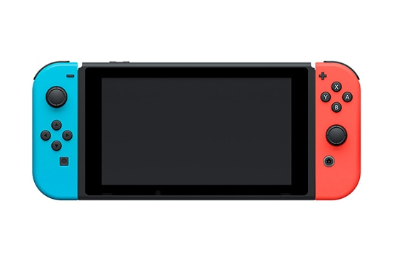
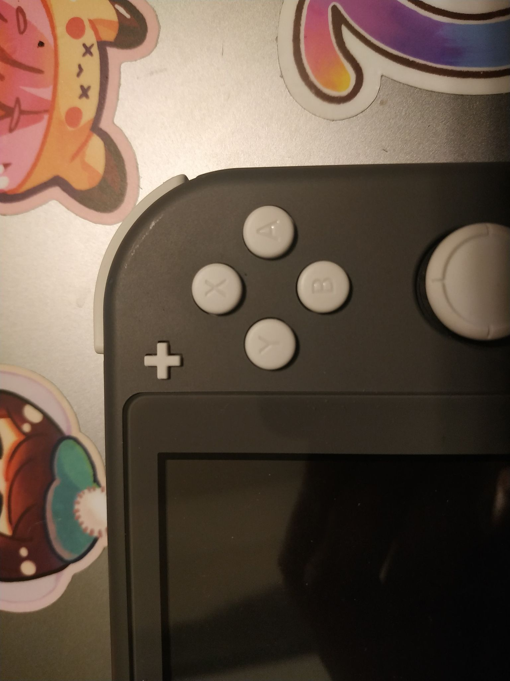

The first image is the Nintendo Switch Lite and the second image is the Nintendo Switch. The buttons are all the same color, and for the Lite, the contrast between the button and the letter is too low.

Figure 2
Xbox One Controller and Xbox 360 S Controller
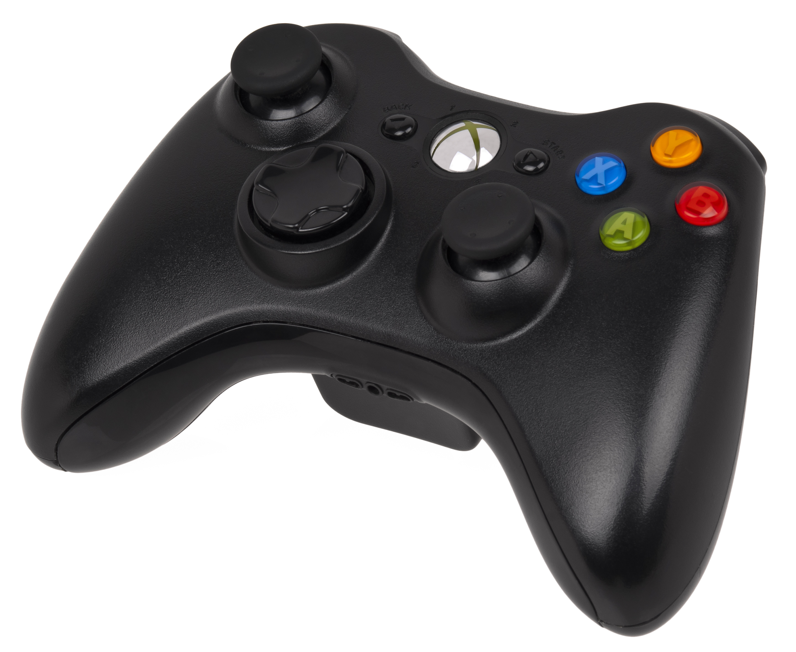
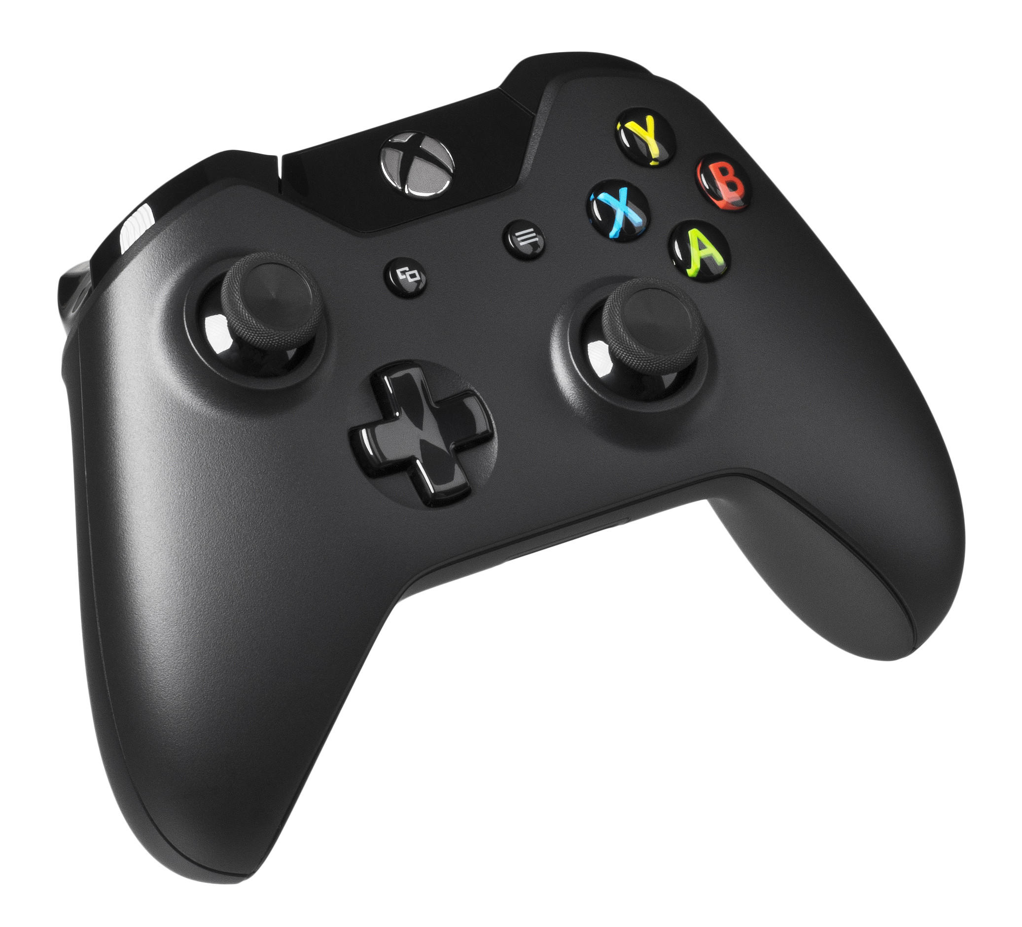

The first image is the Xbox One controller (Amos, 2014) and the second image is Xbox 360 S controller (Amos, 2011). The Xbox offers color-coded labeling.

